**II. WHY AGILE**

Introduction

Lesson Introduction

Welcome to the lesson on why Agile has taken the market by storm in today's digital age.

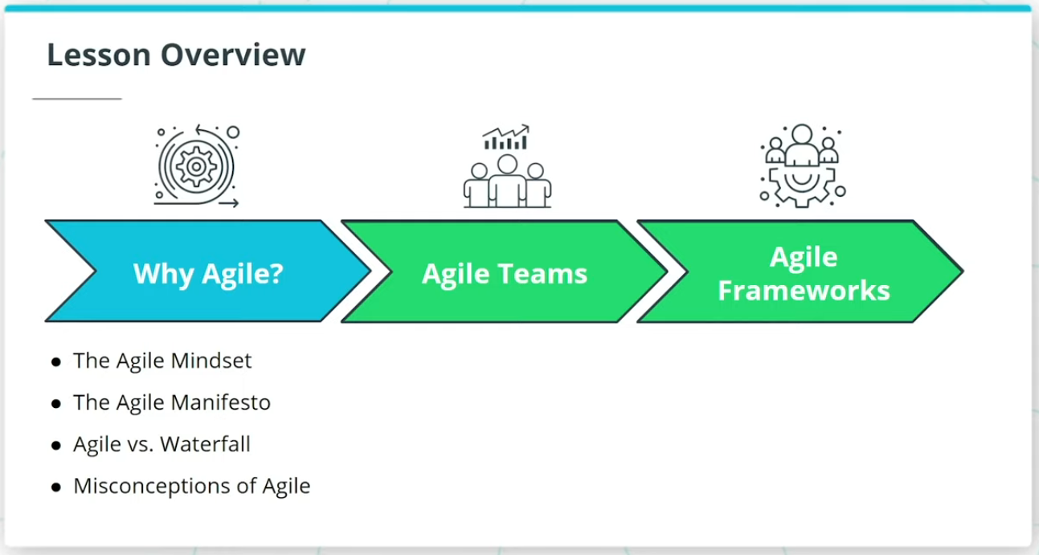

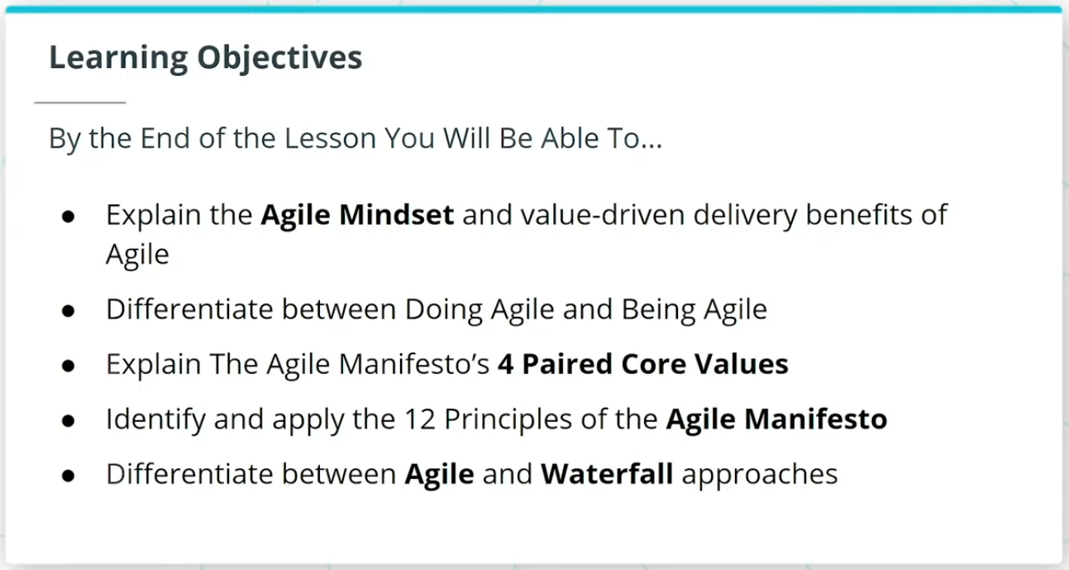

### **What We Will Cover In This Lesson**

In this lesson, we will focus on the foundational theory behind Agile. We will discuss:

* The Agile Mindset and how it sets the tone for ‘Being’ Agile versus just ‘Doing’ Agile
* The Agile Manifesto, and how it is seen as the foundational set of 4 Paired Core Values and 12 Principles that sets the foundation for all Agile Frameworks
* How Agile differs from the more traditional Waterfall approach to product development

We will wrap up the lesson with an important discussion on common misconceptions about Agile.

### **By the End of the Lesson, You Will Be Able To...**

* Explain the Agile Mindset and value-driven delivery benefits of Agile
* Differentiate between Doing Agile and Being Agile
* Explain The Agile Manifesto’s 4 Paired Core Values
* Identify and apply the 12 Principles of the Agile Manifesto
* Differentiate between Agile and Waterfall approaches

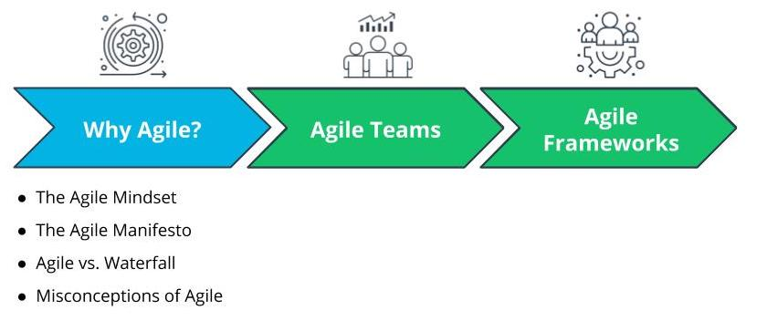

What We Will Cover In This Lesson

# Why Agile

## Why Are Organizations Adopting Agile Part 1

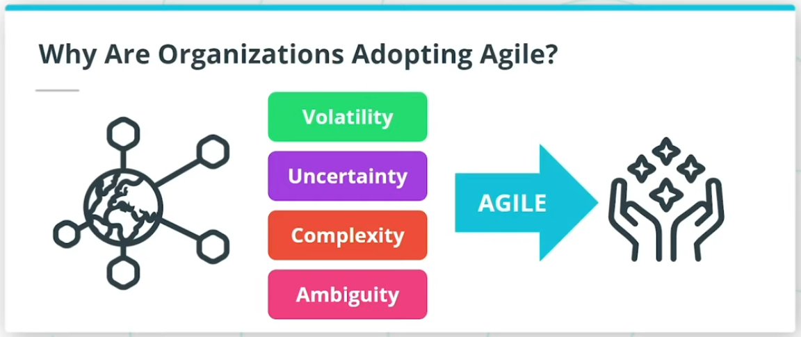

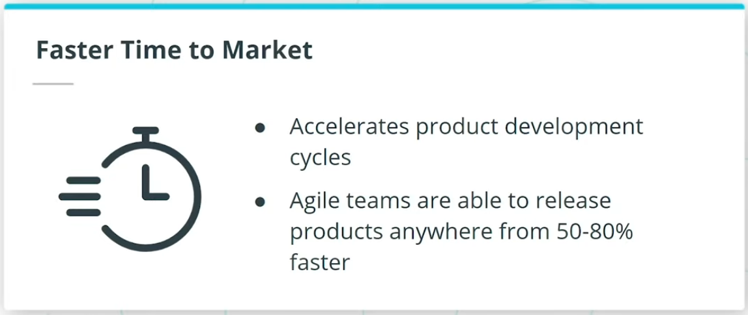

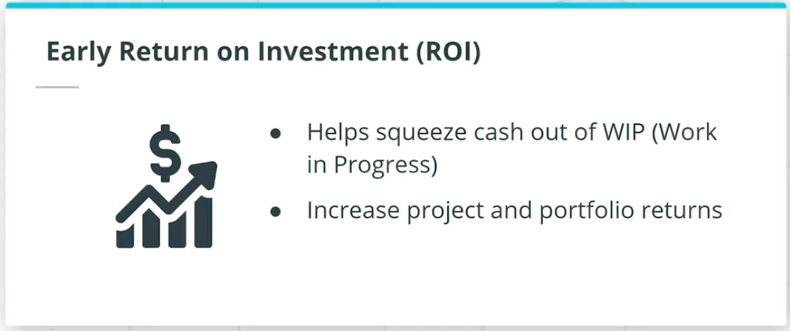

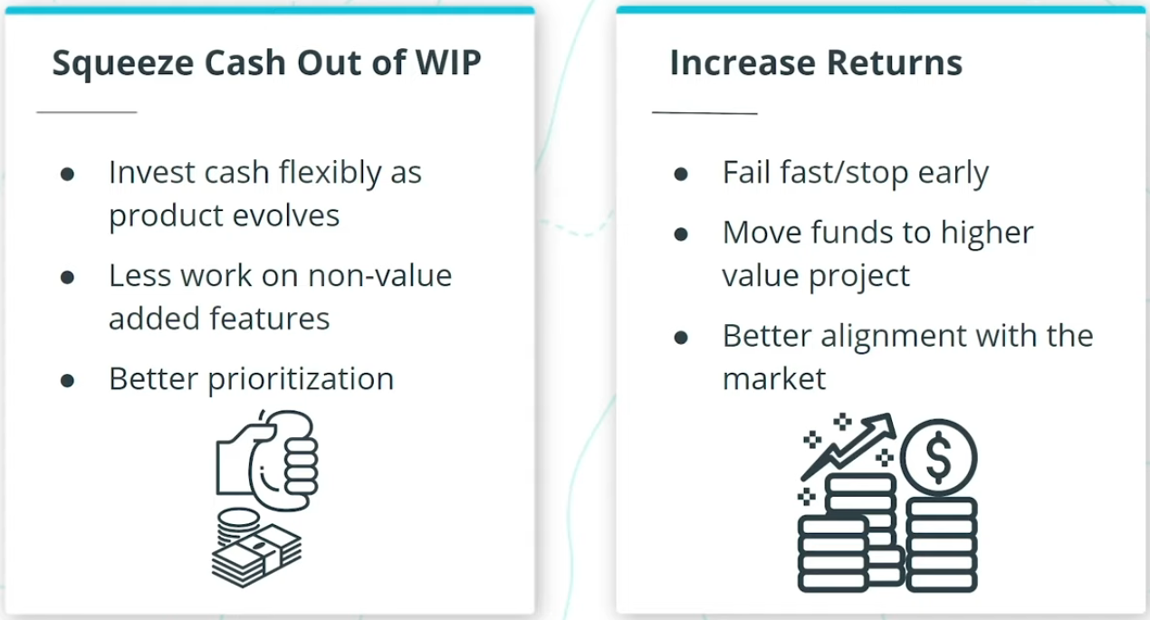

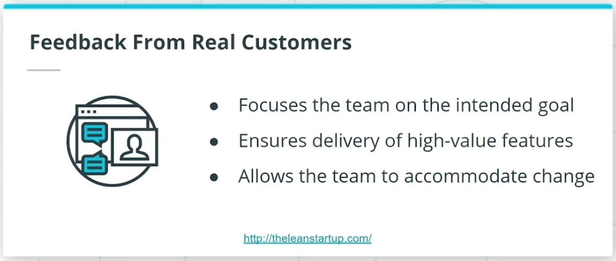

So, why are forward-thinking organizations rapidly adopting Agile? And why are we seeing that global professional bodies such as The Project Management Institute (PMI) in their PMBOK Guide and The International Institute of Business Analysis (IIBA)’s BABOK Guide, have incorporated and highlighted the importance of Agile in project management, business analysis, and other product delivery activities?

In an increasingly interconnected and competitive global marketplace, I am seeing Agile being leveraged by successful organizations across the globe to thrive in today’s digital age. Agile enables organizations to predictably deliver value in a world where we are constantly being challenged with Volatility, Uncertainty, Complexity, and Ambiguity. Organizations that I have seen go through Agile transformation have benefited from the following:

* Faster time to market
* Early ROI
* Feedback from Real Customers

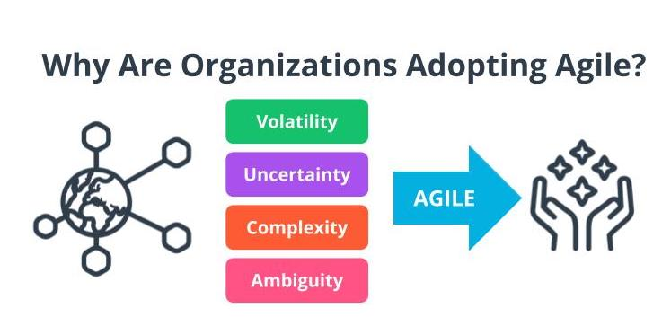

Volatility, Uncertainty, Complexity, Ambiguity

*Note: You are going to learn more about VUCA later in this lesson.*

Why Are Organizations Adopting Agile Part 2

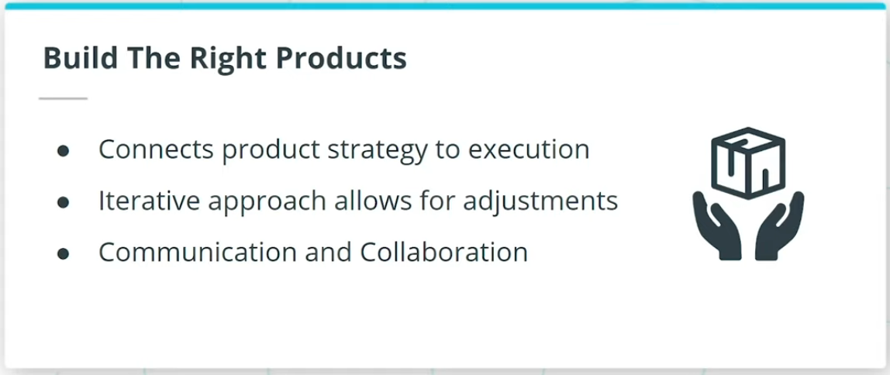

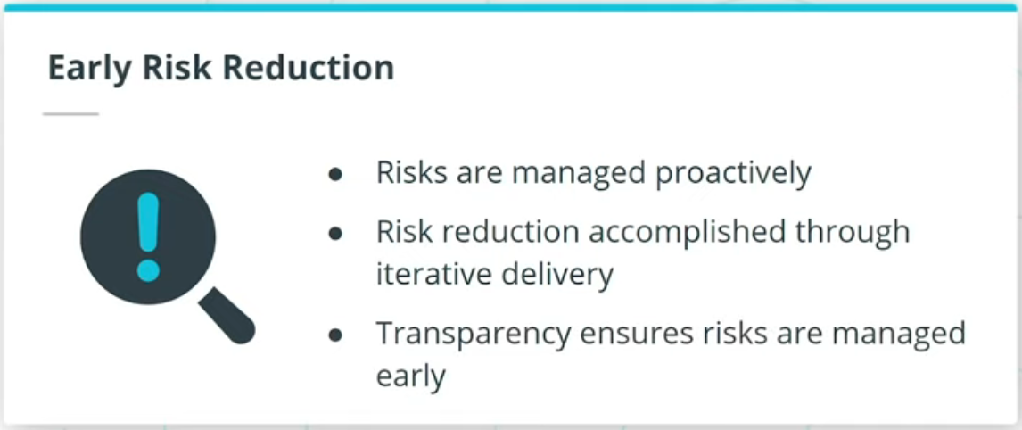

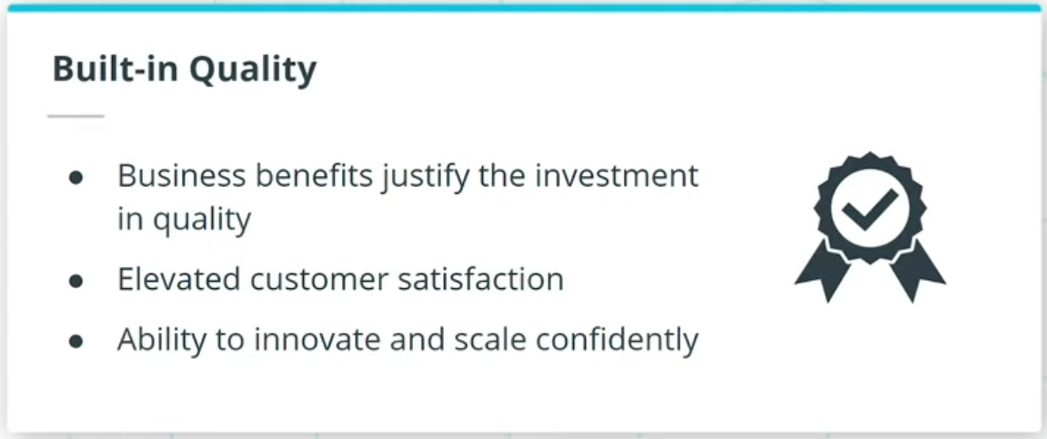

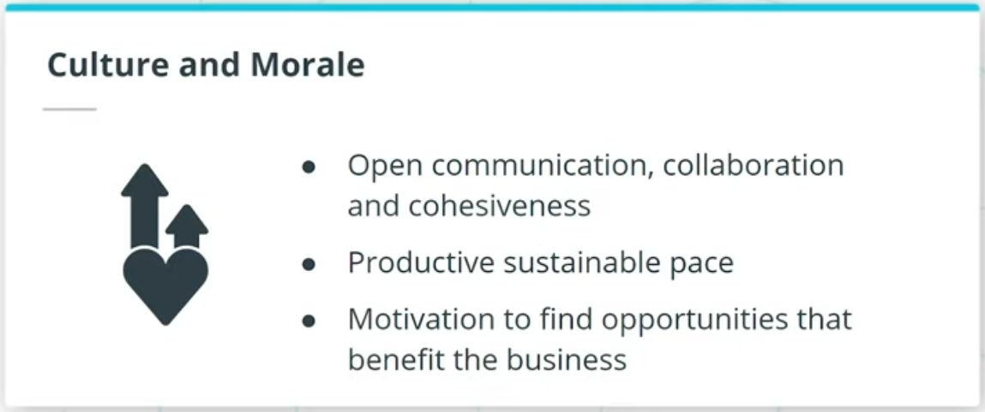

### **Organizations that go through Agile transformation have also benefited from:**

* Build the right products
* Early risk reduction
* Built-in quality
* Culture and morale

## Efficiency vs. Effectiveness

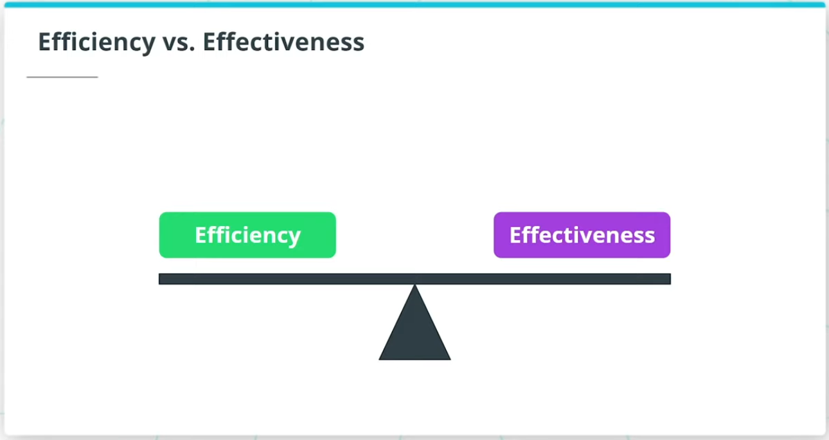

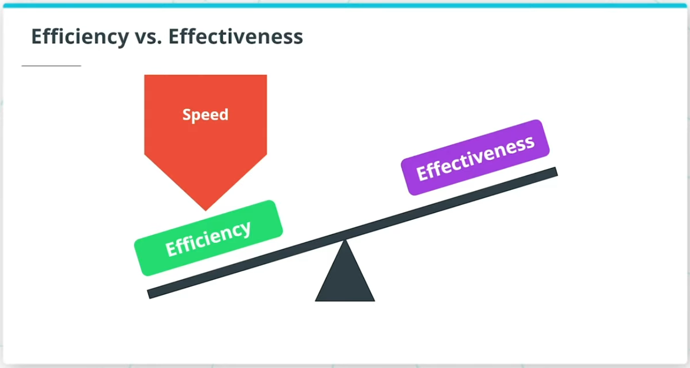

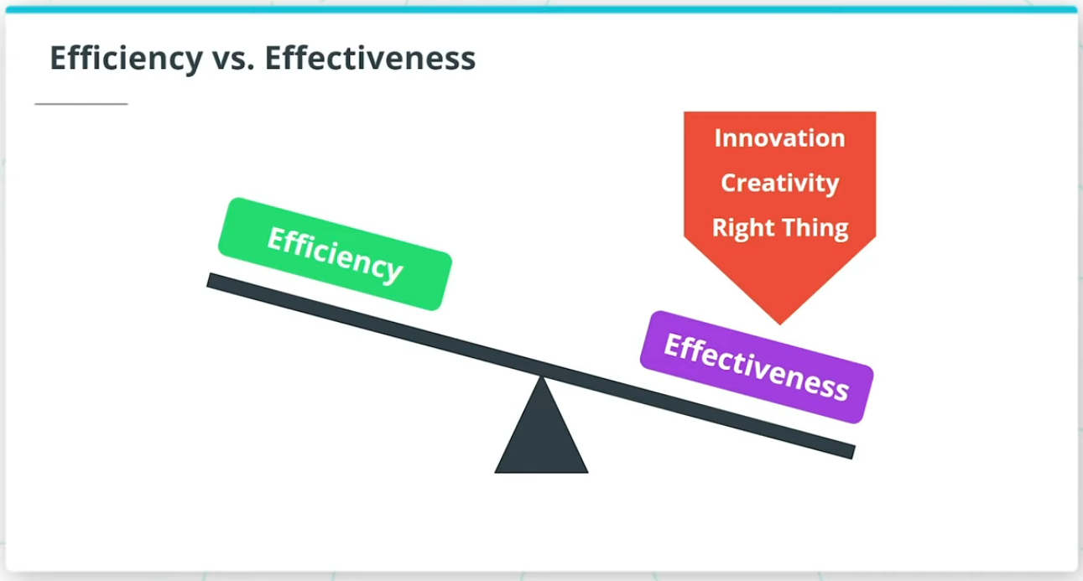

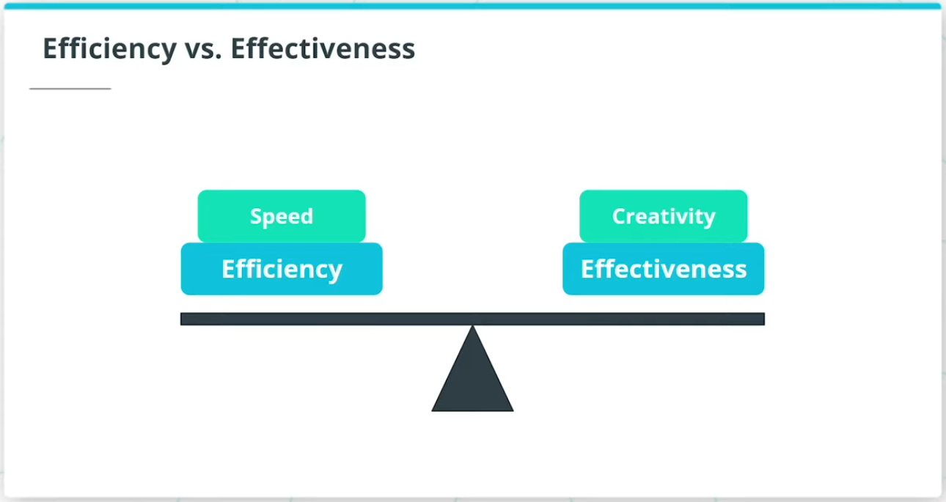

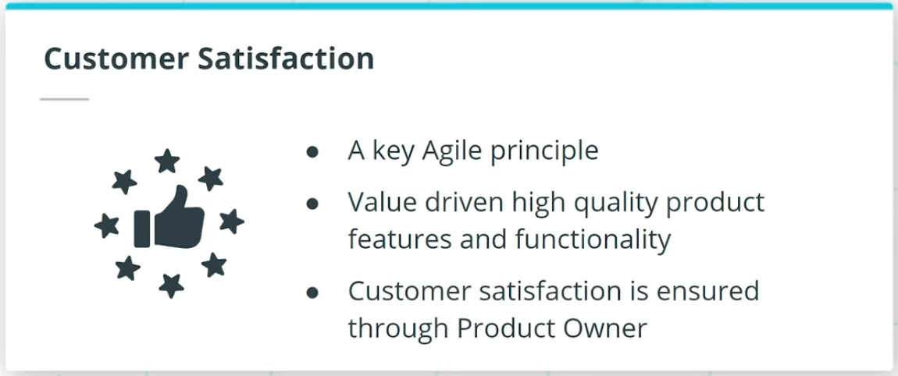

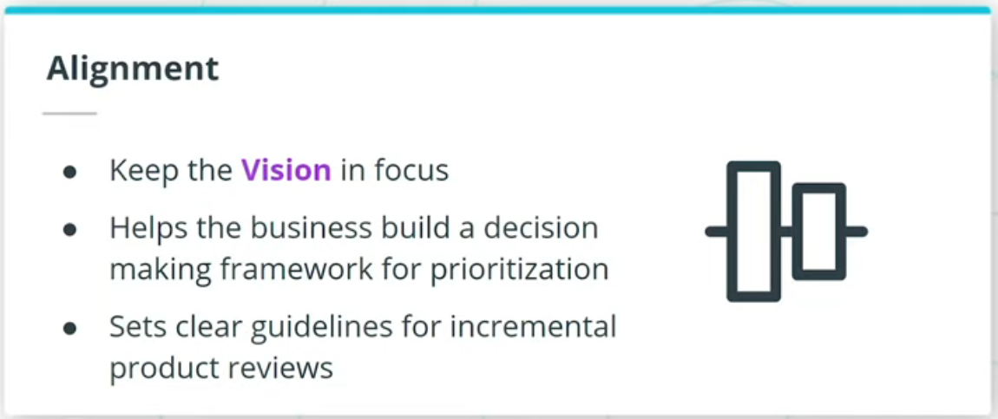

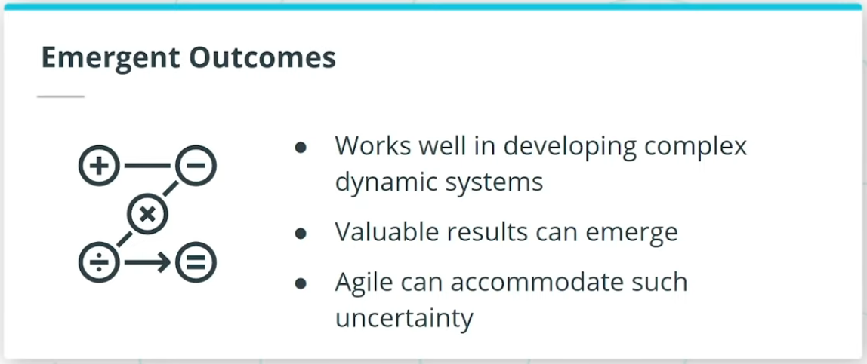

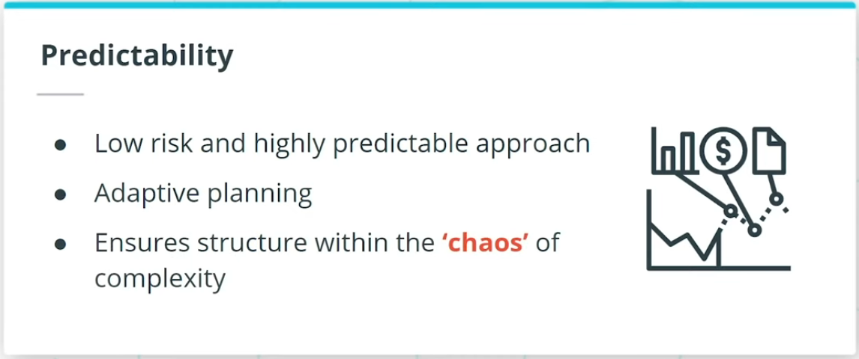

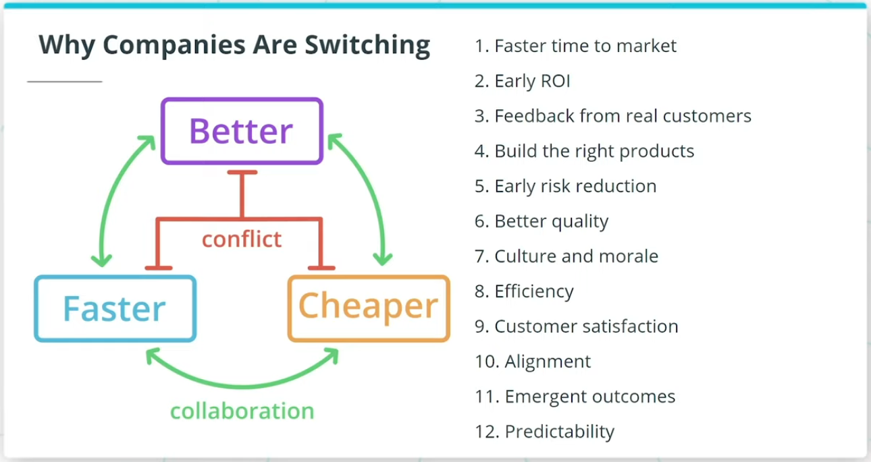

### **Efficiency and effectiveness is a fine balancing act that Agile recommends.**

If you’re only focused on going fast, you prioritize efficiency.

If you’re trying to focus on innovation, creativity, and making sure you’re working on the right thing, you need to focus on effectiveness.

This is often done at the cost of efficiency.

Agile ensures a balanced approach whereby Agile Teams ensure there is a balance between speed and creativity.

Agile transformations also benefit from:

* Customer Satisfaction
* Alignment
* Emergent Outcomes
* Predictability

Organizations want to use Agile to get there by developing products better, faster, and cheaper.

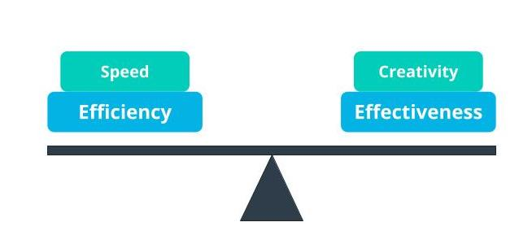

Agile Balances Efficiency And Effectiveness

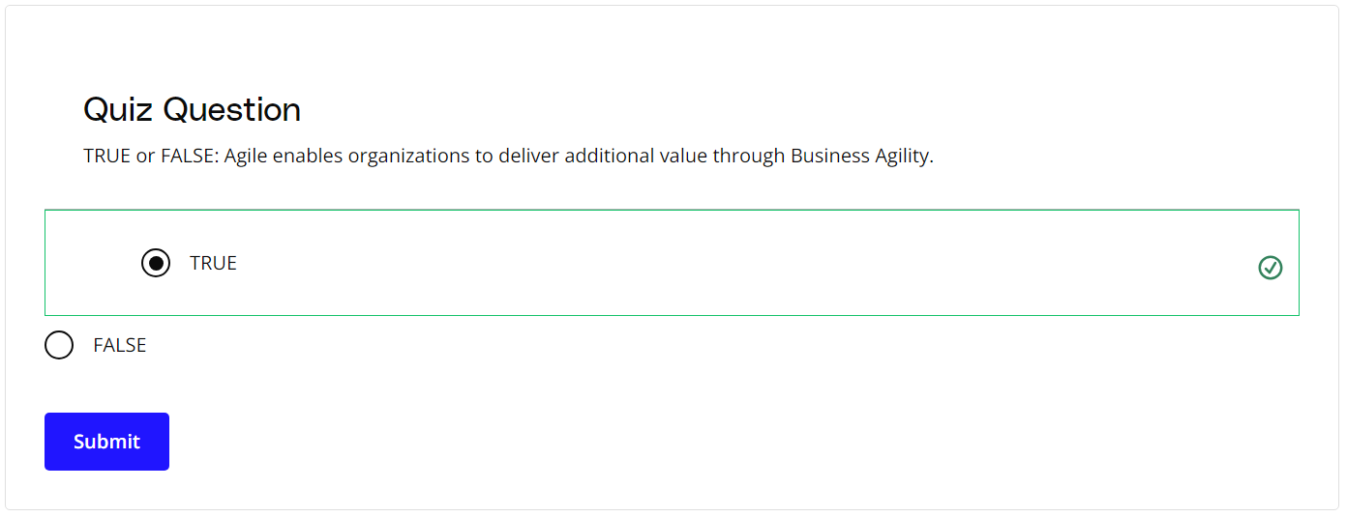

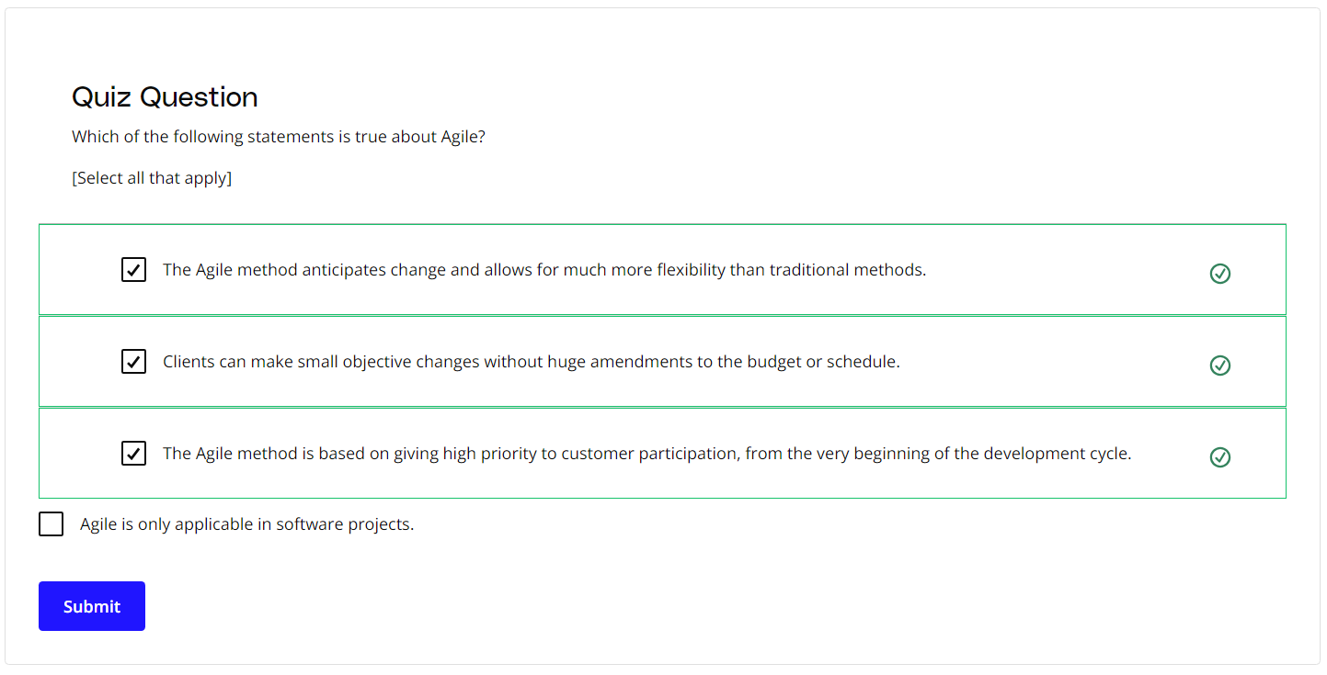

### **New Terms**

* **Ambiguity**: Ambiguity refers to a lack of clarity, such as not having a clear understanding of the genuine needs of the customer and end-users
* **Complexity**: Complexity exists when there are many interconnected parts and variables that influence each other
* **Muda**: Lean principles refer to the Japanese term Muda as waste; Agile teams focus on the removal of non-value adding tasks that are seen as Muda
* **Product Owner**: A business proxy or representative of the business users who is the Voice of the Customer (VOC)
* **Return on Investment (ROI)**: Return on investment (ROI) is calculated as the ratio between net profit and cost of investment over a defined period of time
* **Uncertainty**: The extent to which an organization can confidently predict or forecast the future; more uncertainty makes it harder to predict
* **Voice of the Customer**: A term used to articulate the steps to capture customer's needs
* **Volatility**: Volatility is when there are unexpected or unstable possibilities that may influence the work being done
* **VUCA**: Volatility, Uncertainty, Complexity, Ambiguity
* **WIP (Work in Progress)**: The work that has been started but not yet completed

### **Additional Resources**

* [**The Lean Startup**](http://theleanstartup.com/) by Eric Ries

# How Experts Approach Agile

## Thinking About Agile

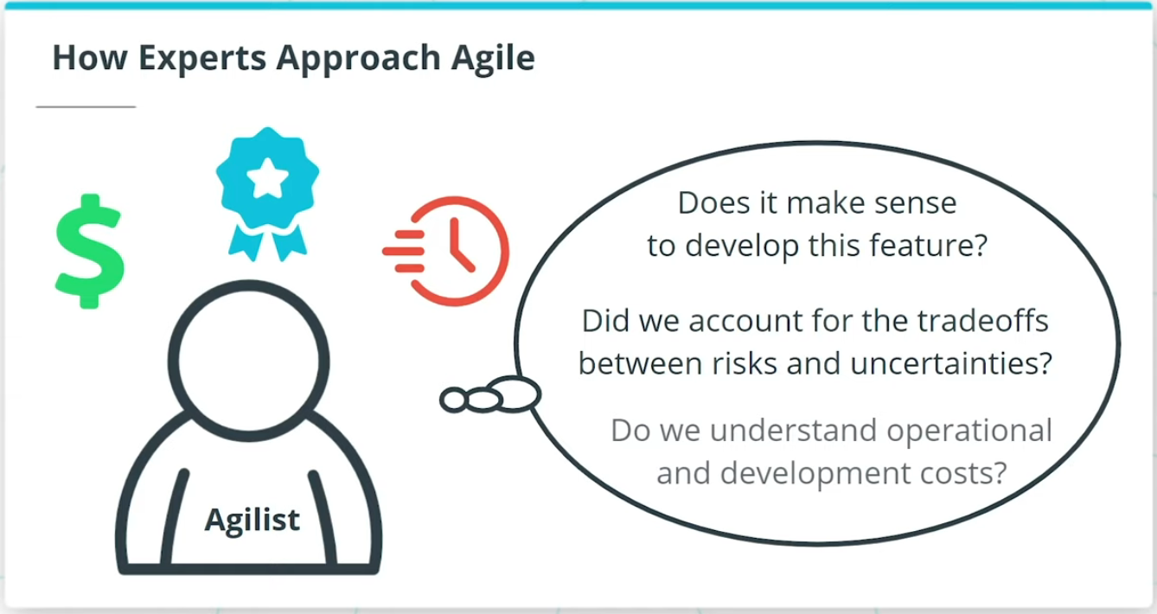

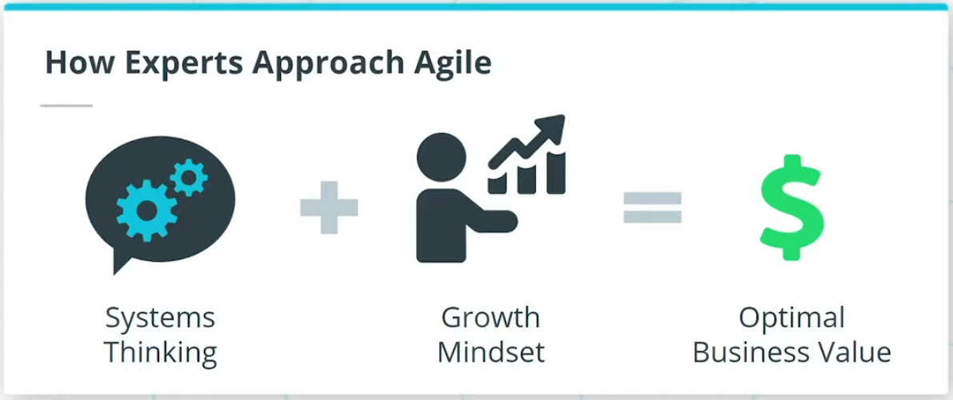

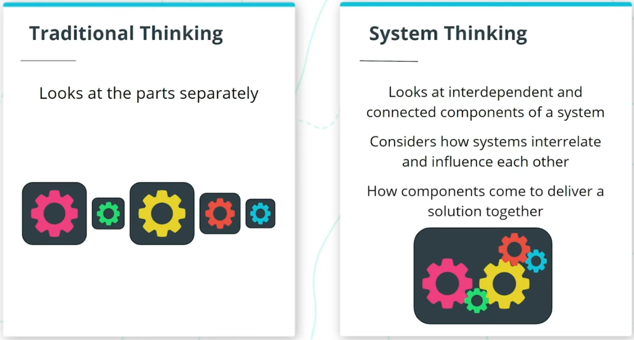

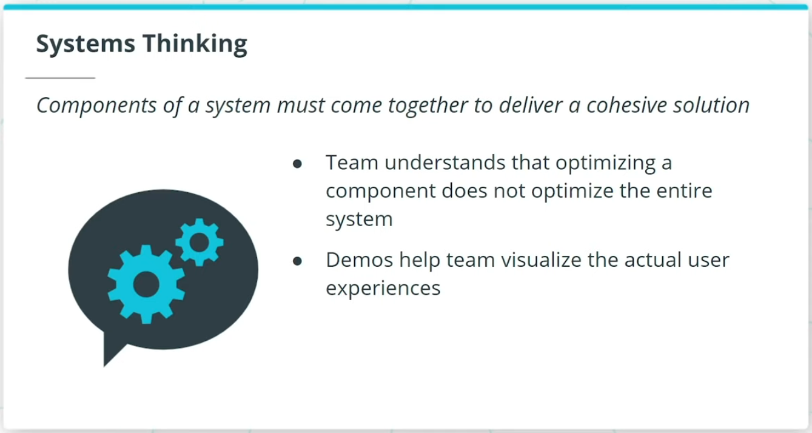

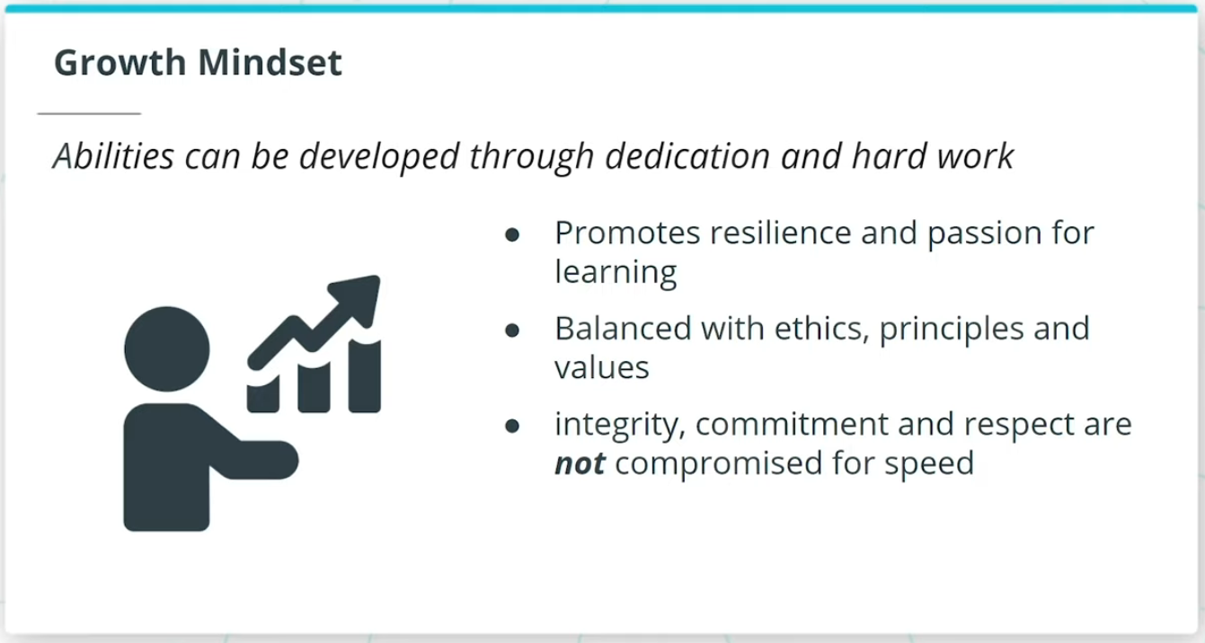

### **Agile Is Based on a Systems Thinking Approach and a Growth Mindset**

* Agilists adopt a practical and realistic approach to delivering the best value, and quality, in the shortest sustainable time.
* A Systems Thinking approach, reinforced by a Growth Mindset, helps Agile experts deliver optimal business value.
* Systems thinking takes a holistic approach in which the Agile Team looks at the way a system's components interrelate and influence each other and how these components come together within the context of larger systems to deliver a solution.
* In a growth mindset, individuals on a team have the mindset that their abilities can grow through dedication and hard work.

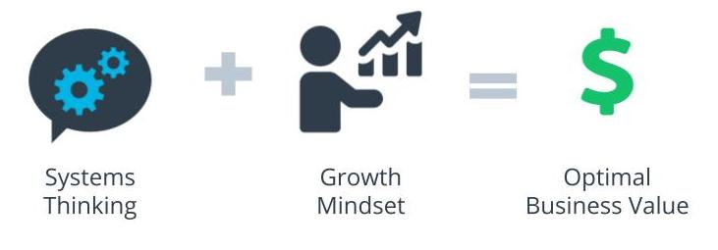

Systems Thinking + Growth Mindset = Optimal Business Value

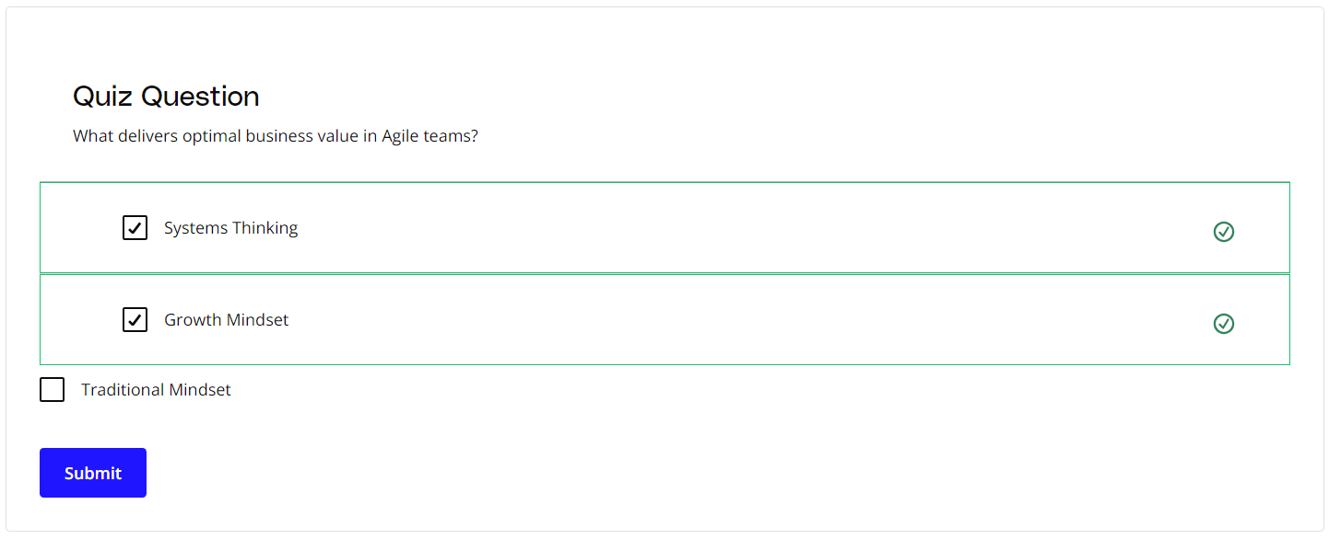

### **New Terms**

* **Growth Mindset**: The mindset that an individual's abilities can grow through dedication and hard work
* **Systems Thinking**: A holistic approach that looks at the way a system's components interrelate and influence each other and how these components come together within the context of larger systems to deliver a solution

### **Additional Resources**

* Brad Smith and Carol Ann Browne. ***Tools and Weapons: The Promise and the Peril of the Digital Age***. Penguin, 2019.  
  In this book, Brad Smith and Carol Ann Browne share how one of the world's largest and most powerful companies leverages Agile practices to overcome today's challenges in the global marketplace.

# The Agile Mindset

## What Is the Agile Mindset?

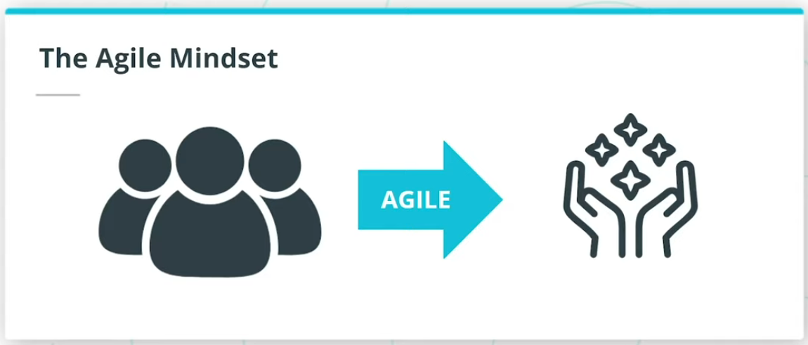

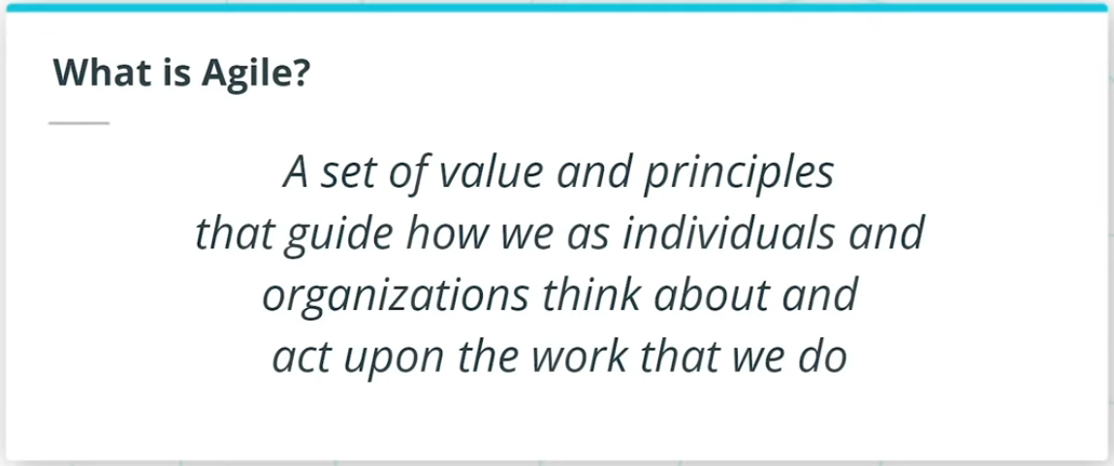

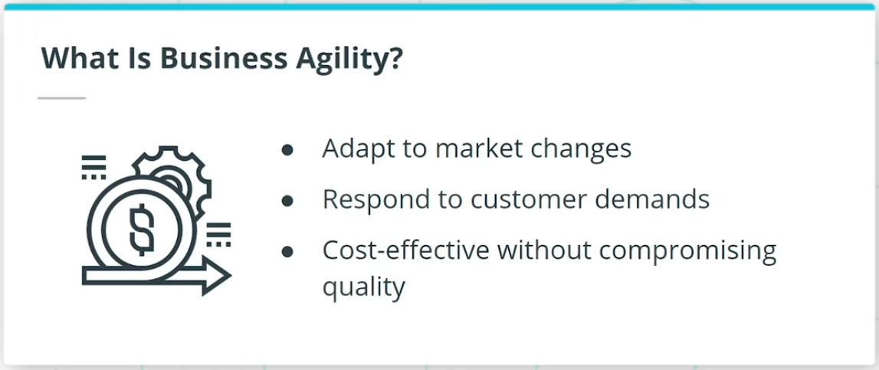

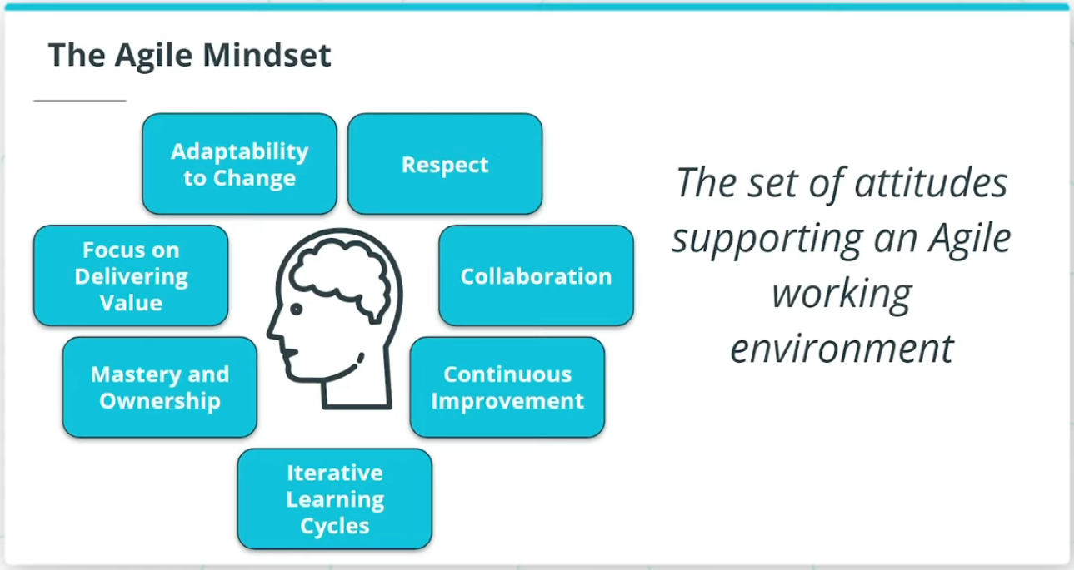

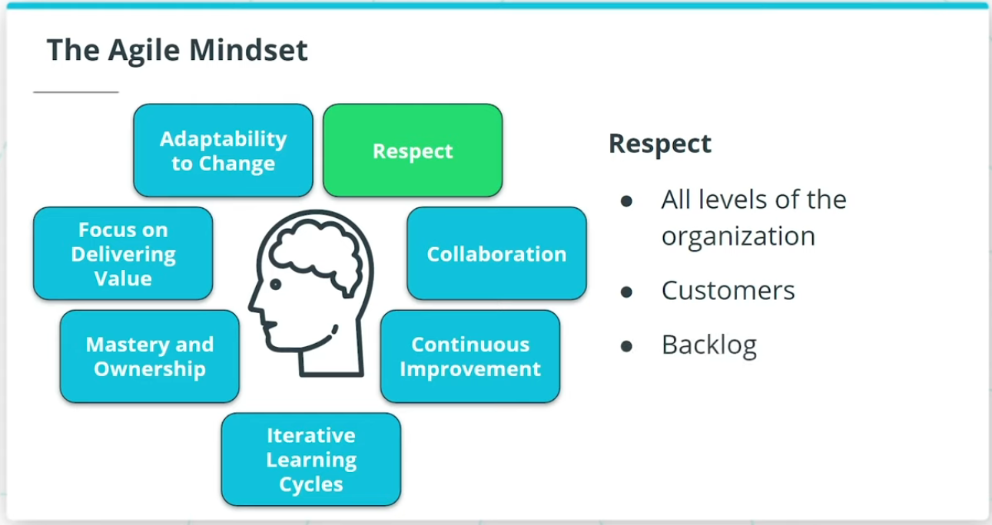

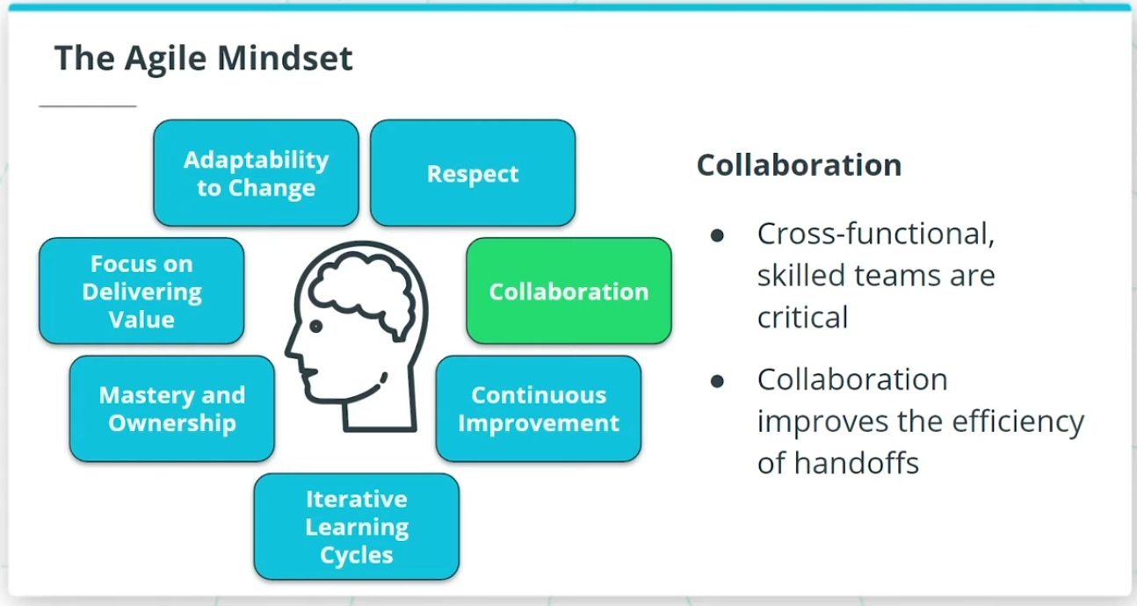

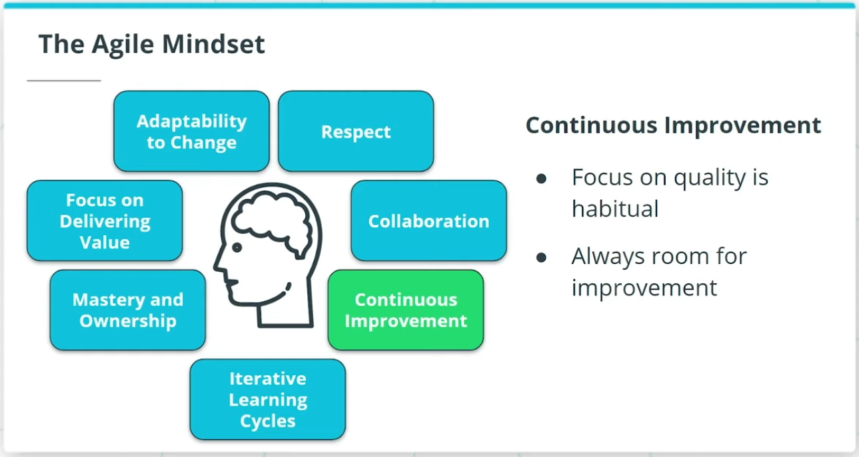

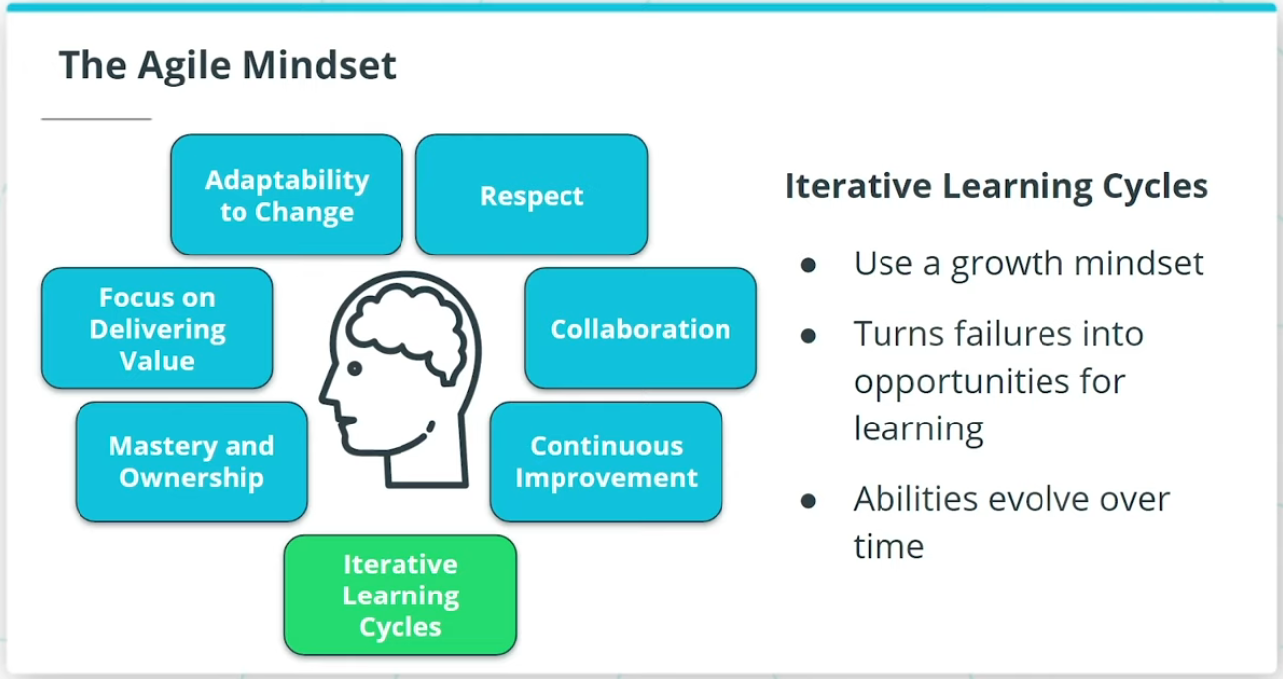

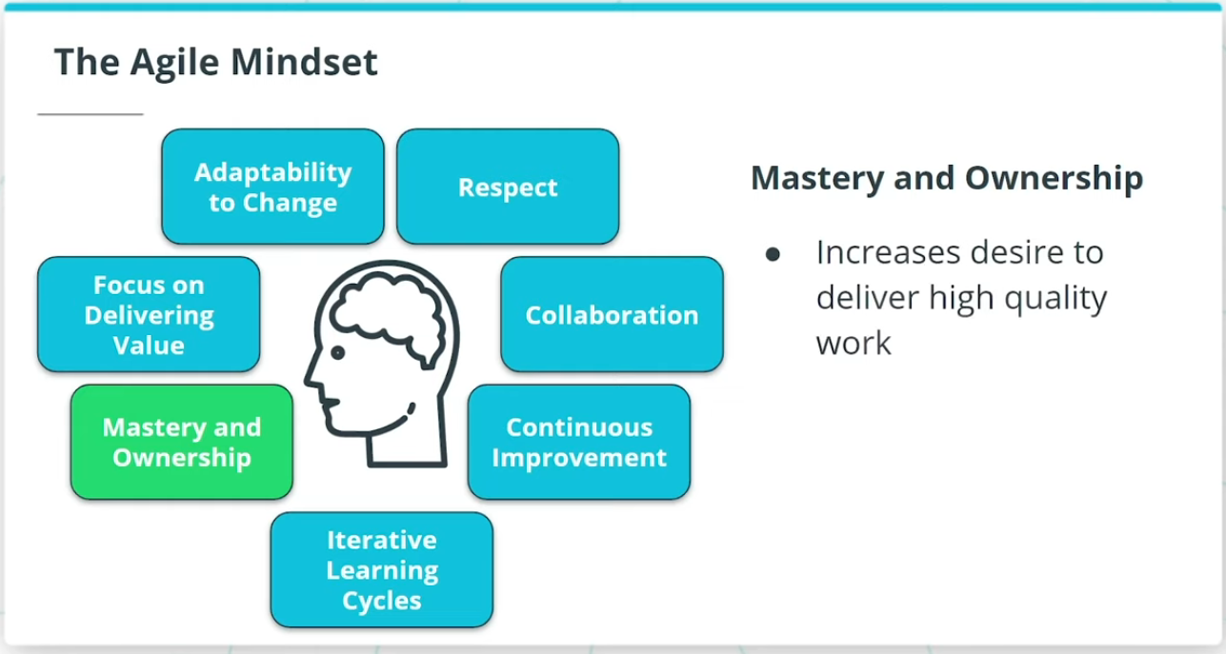

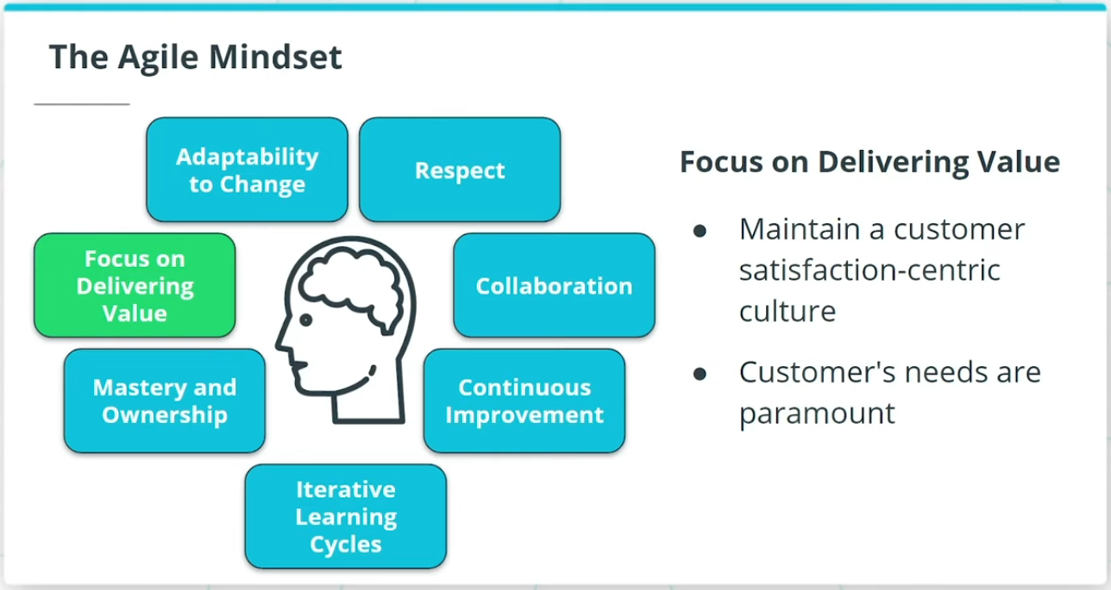

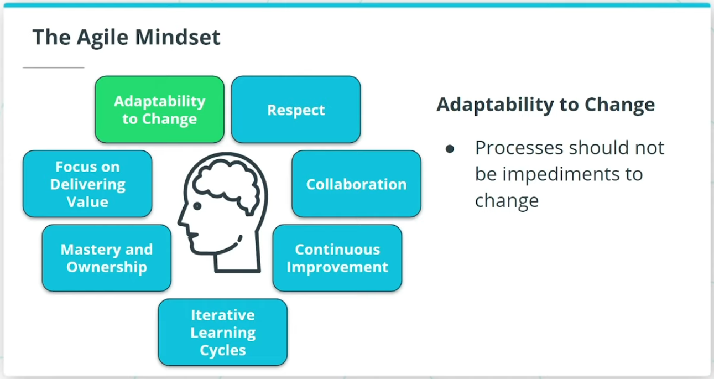

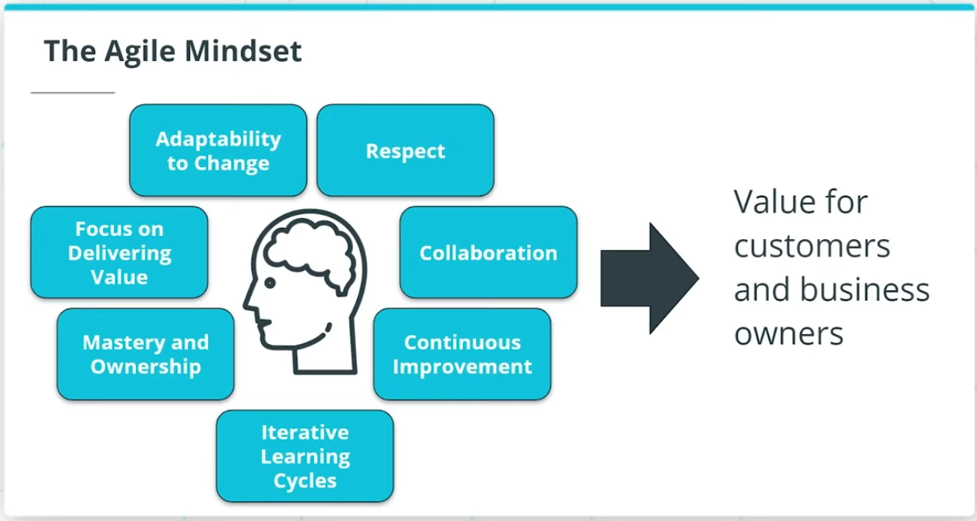

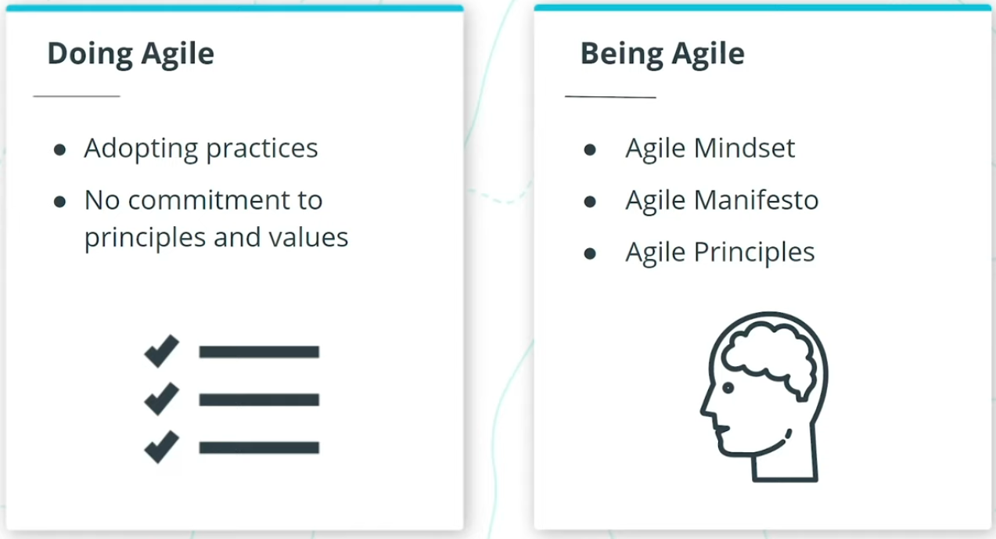

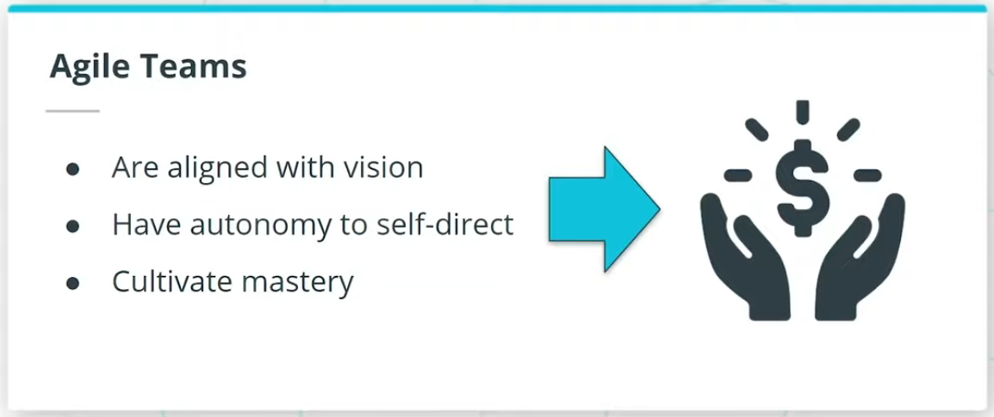

### **Agile permits teams to flourish in an environment that is increasingly Volatile, Uncertain, Complex, and Ambiguous, also known as VUCA.**

* Volatility is when there are unexpected or unstable possibilities that may influence the work being done
* Uncertainty refers to the extent to which an organization can confidently predict or forecast the future
* Complexity exists when there are many interconnected parts and variables that influence each other
* Ambiguity refers to a lack of clarity, such as not having a clear understanding of the genuine needs of the customer and end-users

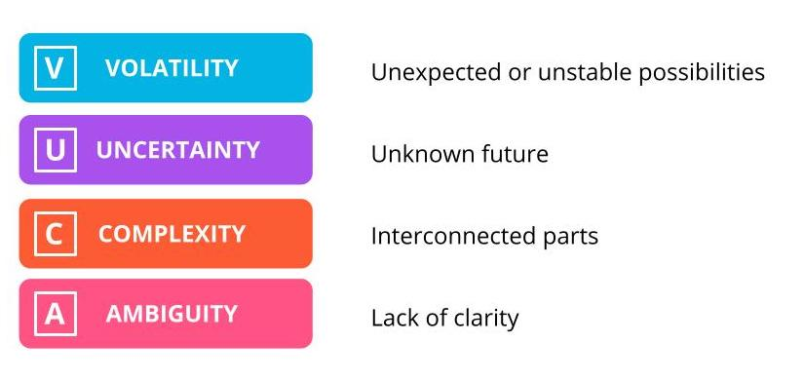

Volatility, Uncertainty, Complexity, Ambiguity (VUCA)

### **Business Agility**

Agile is a set of principles that guide how we as individuals, as teams and as organizations think about, as well as act upon, the work that we do.

Business agility is the ability of an organization to:

* Adapt quickly to market changes
* Respond rapidly and flexibly to customer demands that make business sense
* Adapt and lead change in a productive and cost-effective manner with no compromise to quality

### **The Agile Mindset**

When we talk about an Agile Mindset, we include:

* Respect
* Collaboration
* Continuous Improvement
* Iterative Learning Cycles
* Mastery and Ownership
* Focus on Delivering Value
* Adaptability to Change

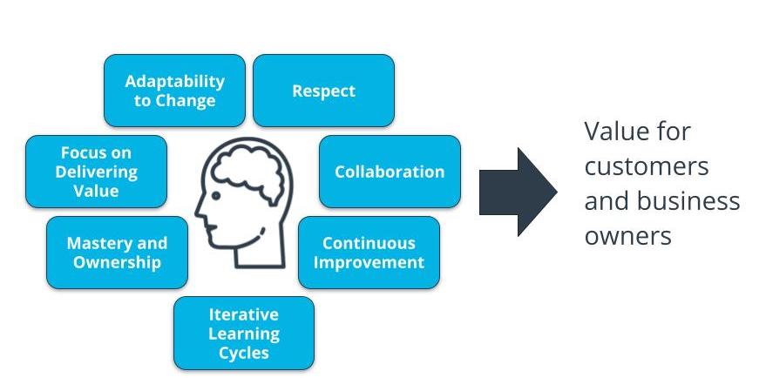

The Agile Mindset

### **Doing Agile vs. Being Agile**

Some organizations and Agile Teams unfortunately just focus on Doing Agile. This equates to simply adopting the practices without committing to or exhibiting agile principles and values.

Being Agile is the foundation that truly elevates individuals, teams, and organizations to unleash their latent potential to deliver monumental and focused value.

### **New Terms**

* **Agile Mindset**: The set of attitudes supporting an agile working environment
* **Being Agile**: When an Agile team lives & breathes Agile principles and values through Agile practices consistently every day
* **Business Agility**: The ability of an organization to adapt quickly to market changes, respond rapidly and flexibly to customer demands that make business sense, as well as adapt and lead change in a productive and cost-effective manner with no compromise to quality
* **Doing Agile**: When an Agile team adopting the practices without committing to or exhibiting Agile principles and values

### **Additional Resources**

* Gil Broza, ***The Agile Mind-Set: Making Agile Processes Work***, 3P Vantage Media, 2015.  
  This book clearly articulates how the missing piece in successfully transforming organizations to Agile is the Agile Mindset.

# Quizzes: The Agile Mindset

## Thinking About the Agile Mindset

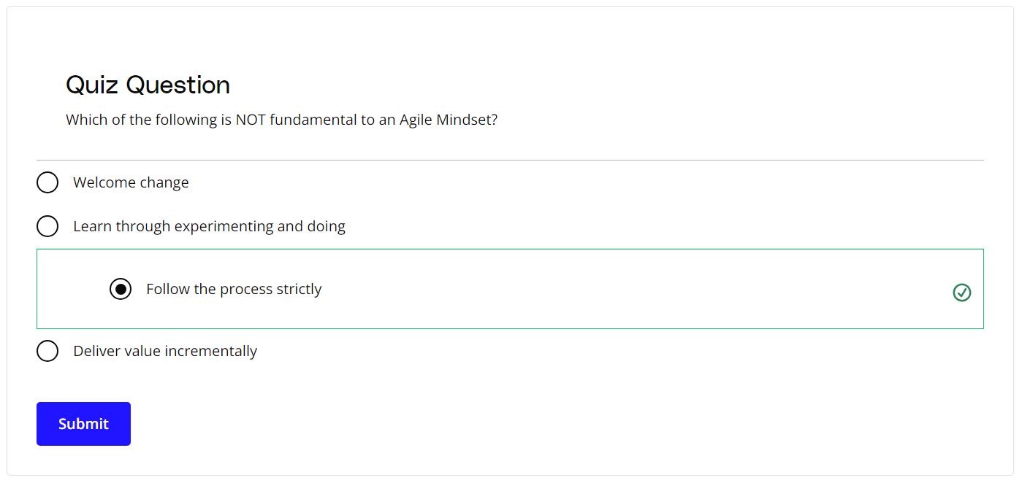

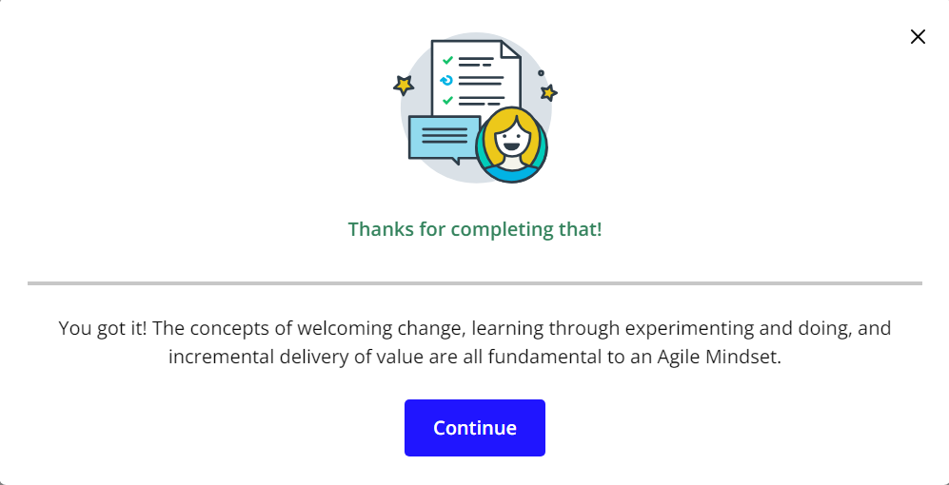

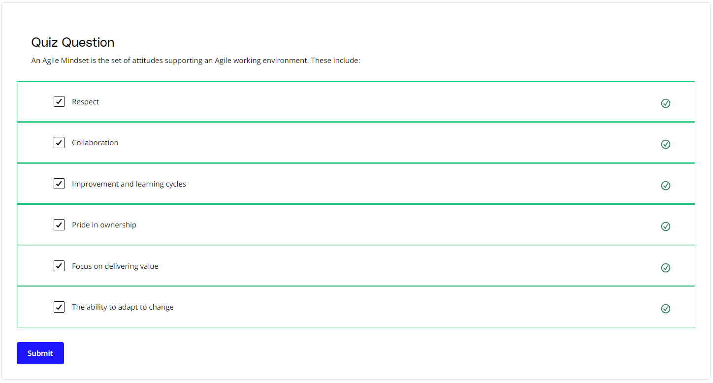

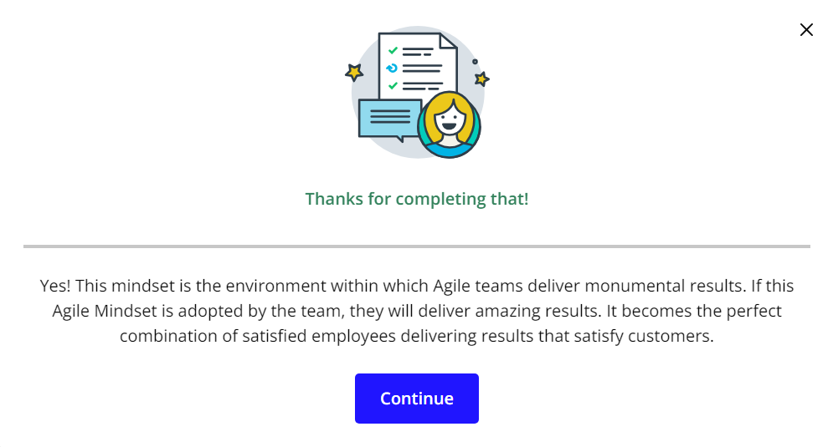

# Exercise: The Agile Mindset

## Applying the Agile Mindset

## Exercise Scenario: SocialKare.gov

SocialKare.gov was launched to allow citizens of Nunamerica to enroll in Social Services provided by the government as a result of a devastating pandemic. Unfortunately, the launch of SocialKare.gov was seen as a disaster from all project management metrics, as well as by its key stakeholders’ low satisfaction ratings. Read what happened in the [**SocialKare.gov Case Study**](https://video.udacity-data.com/topher/2020/September/5f5f6bc7_agnd-c1-foundations-of-agile-socialkare.gov-case-study/agnd-c1-foundations-of-agile-socialkare.gov-case-study.pdf).

You'll also want to download the [**Agile Foundations Course Workbook**](https://video.udacity-data.com/topher/2020/September/5f5f6ba2_agnd-c1-foundations-of-agile-workbook-9-14-20/agnd-c1-foundations-of-agile-workbook-9-14-20.docx). This workbook is in a .docx format, which can be used in most word processing programs including Microsoft Word and Google Docs. To use the workbook in Google Docs, just upload the workbook to your Google Drive and open the document using Google Docs.

***We will be using this scenario and workbook for most of the exercises in this course. We will indicate which worksheet you should fill out for each exercise.***



### **Agile Mindset Anti-Patterns**

Is the SocialKare.gov team operating with an Agile Mindset? Review the Case Study and your notes on the Agile Mindset. What Agile Mindset anti-patterns do you see at SocialKare.gov? Anti-patterns are practices that preventing the Agile mindset from being present and make things worse.

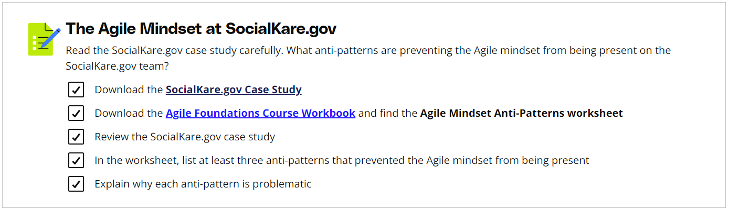

# Solution: The Agile Mindset

## My Solution

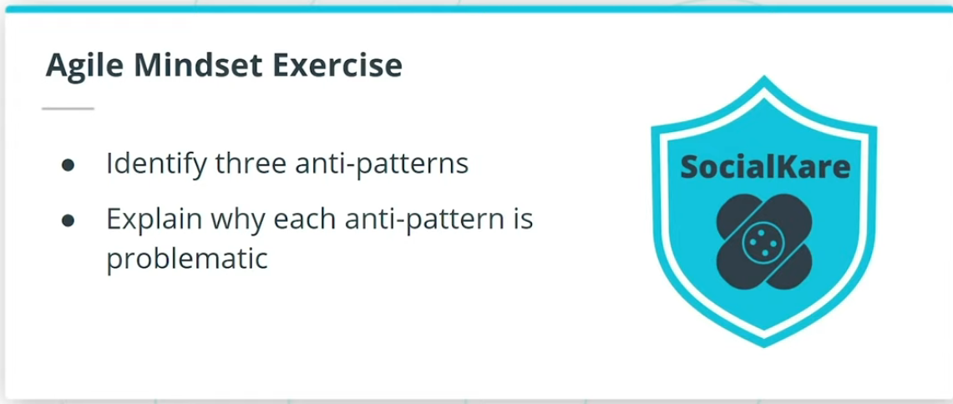

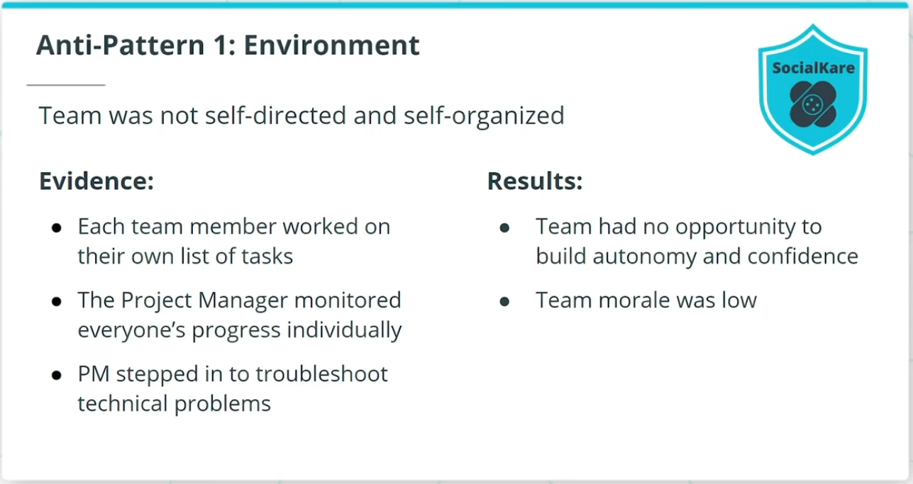

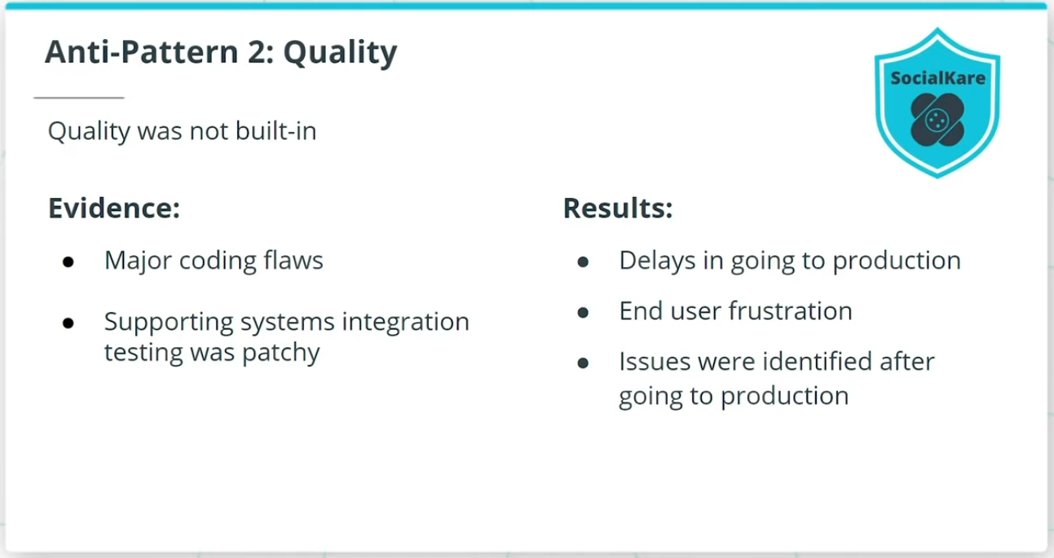

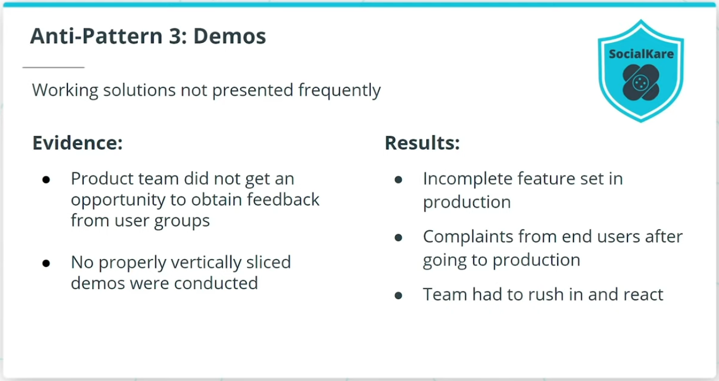

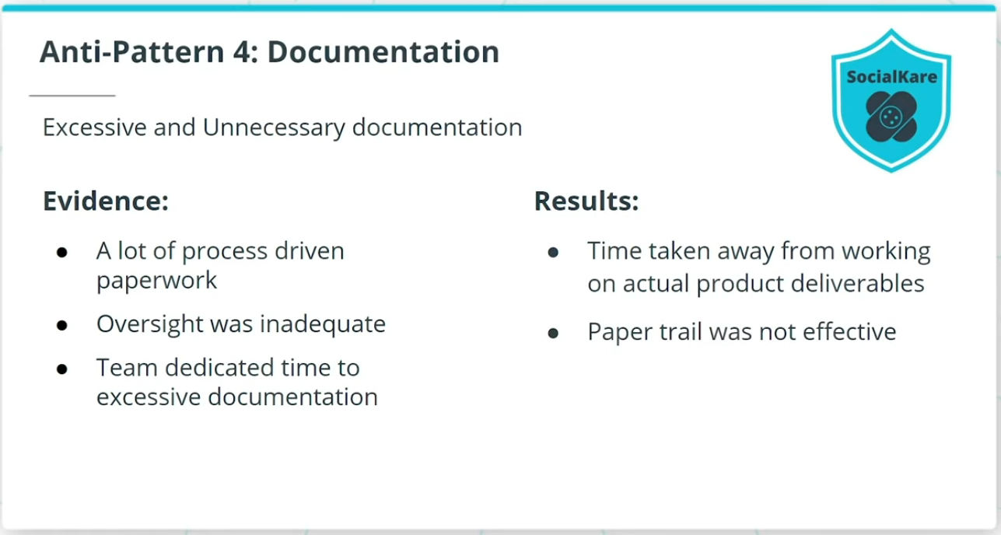

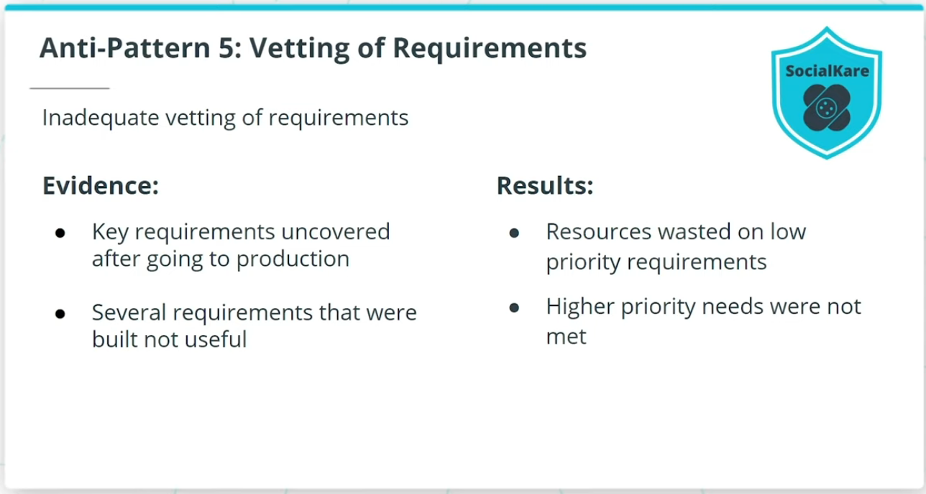

### **The Anti-Patterns I Found:**

* The Project Manager did not build an environment of making the team self-directed and self-organized. As a result, the team did not get an opportunity to build autonomy and confidence without relying on the Project Manager to step in to troubleshoot.
* Quality was not built-in iteratively in the product development life cycle. This resulted in delays in going to production, which frustrated both the business leadership and the end-users.
* Interim working solutions were not presented frequently to the business and end-users for proactive buy-in and feedback. This resulted in an incomplete set of features going to production.
* Excessive and not so valuable documentation was required by the project. As a result, the product results were disappointing.
* There was little in the way of ensuring these requirements made business sense throughout the project life cycle. As a result, the resource effort put into lower priority requirements ended up pushing out the higher priority needs.

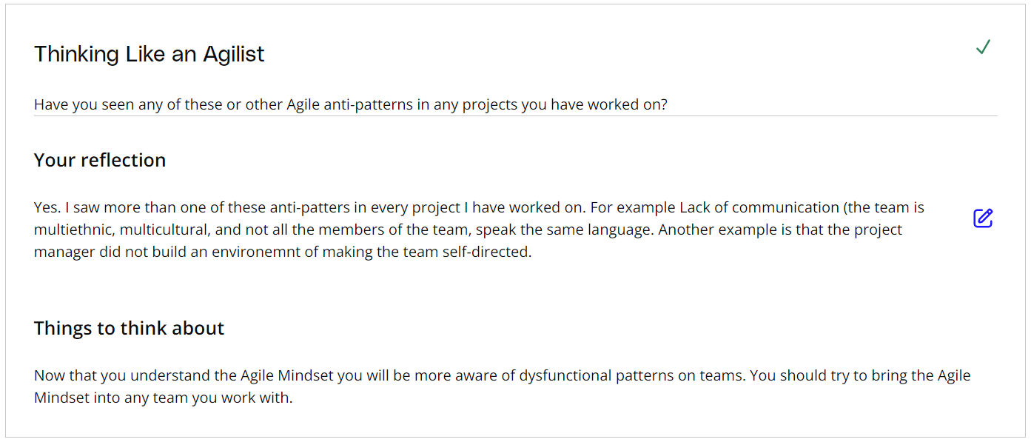

# The Agile Manifesto

## What Is the Agile Manifesto?

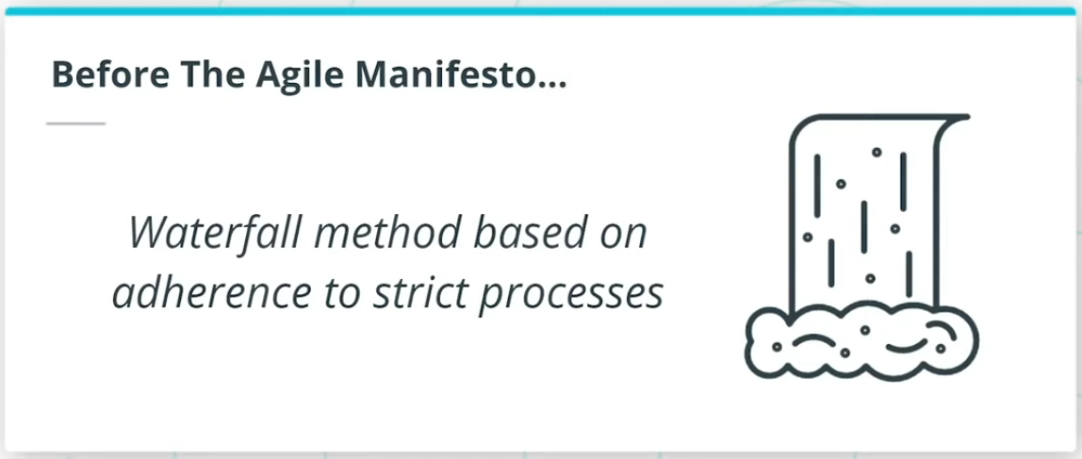

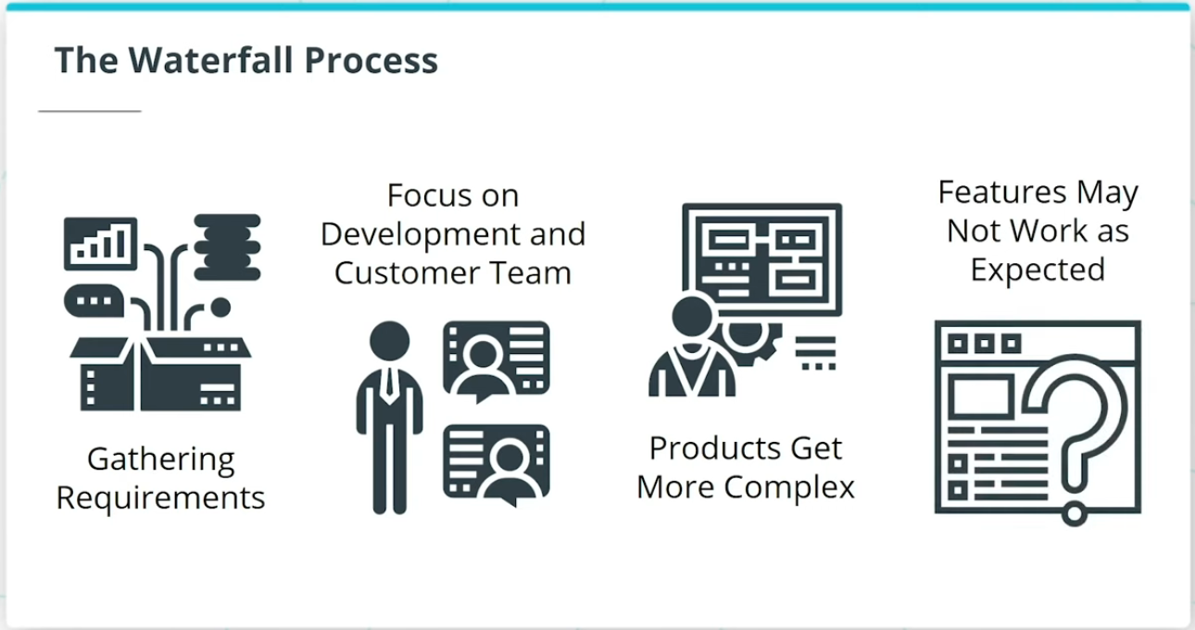

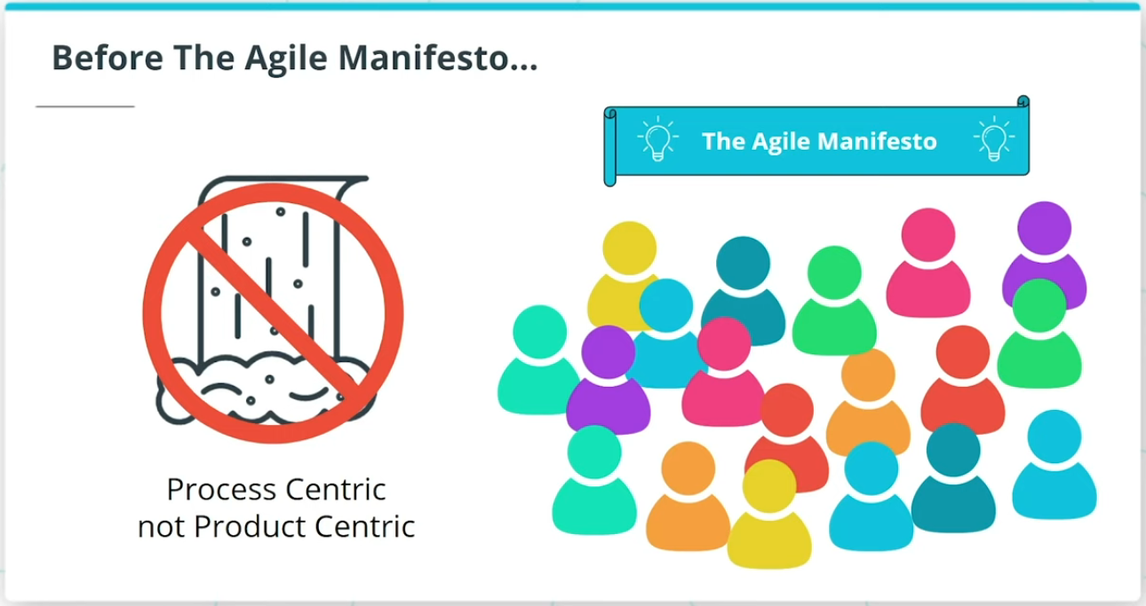

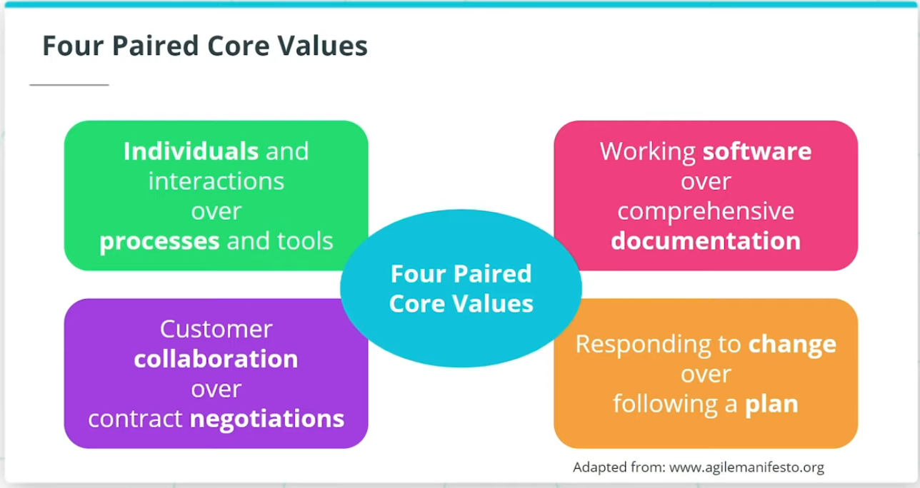

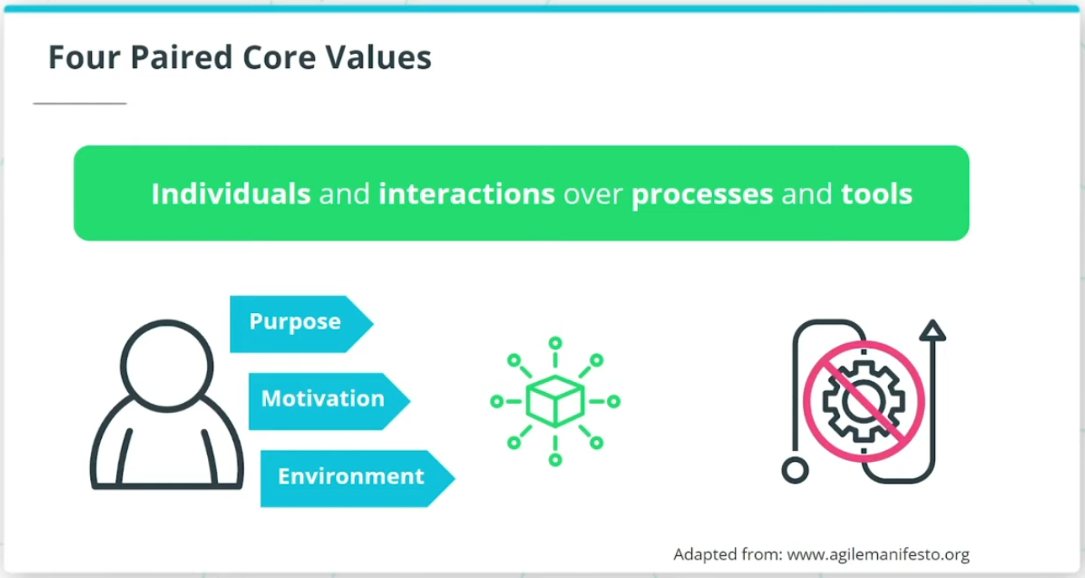

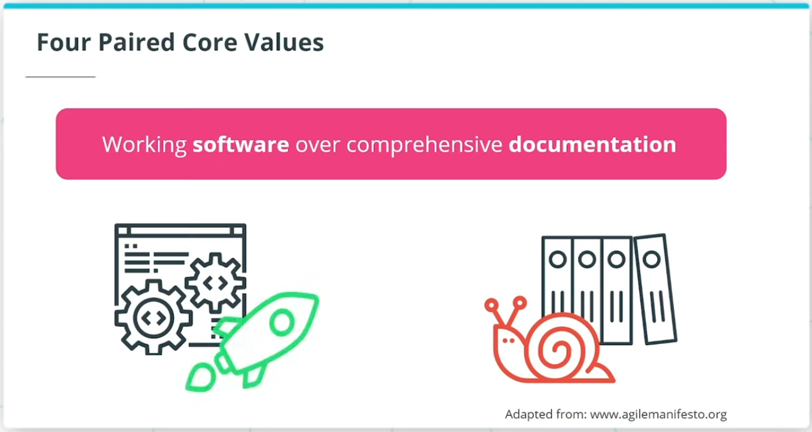

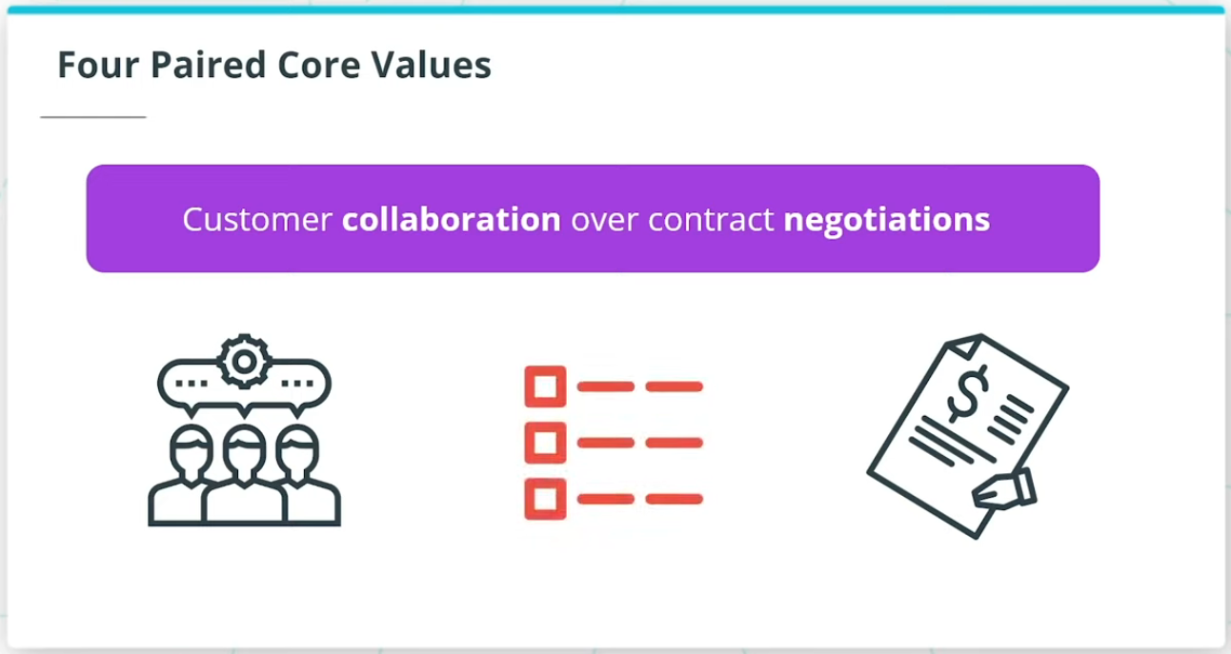

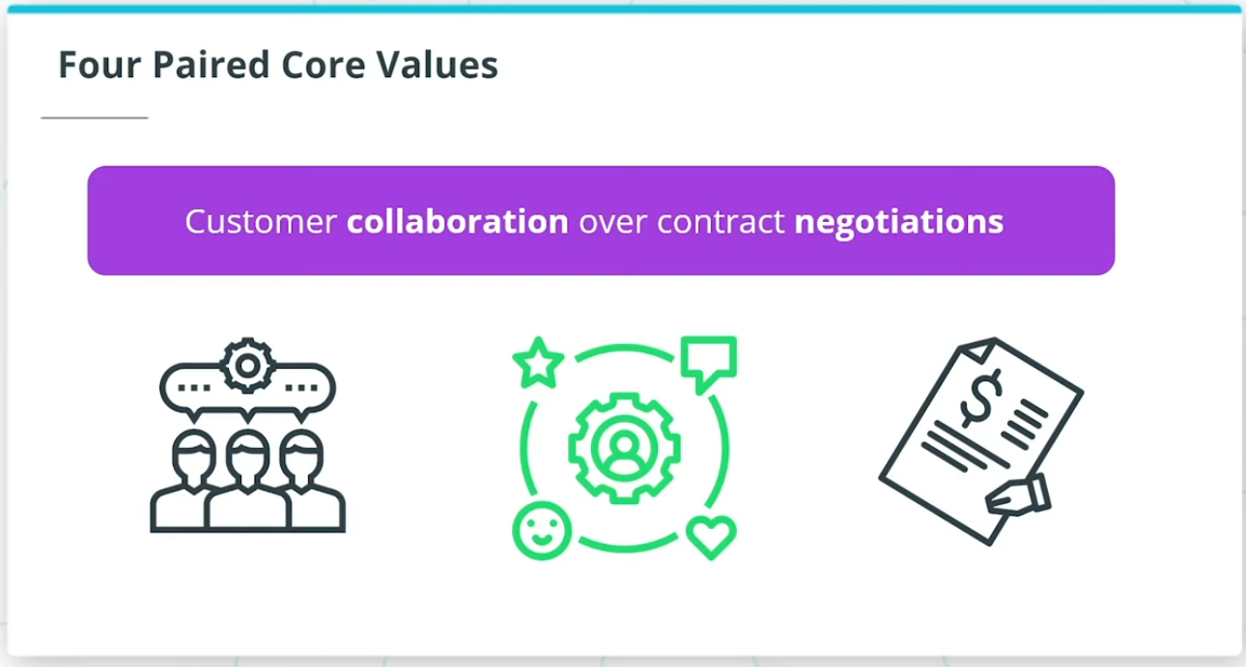

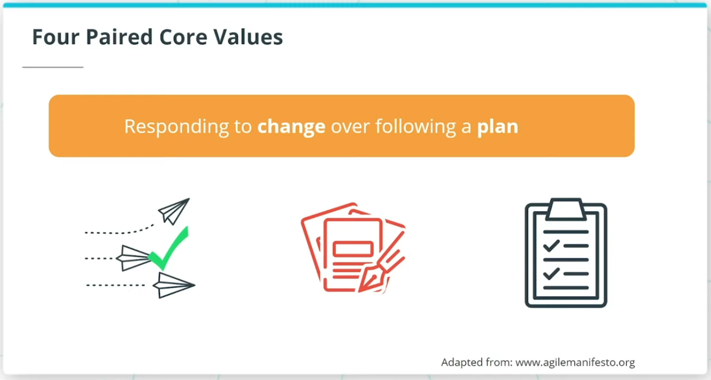

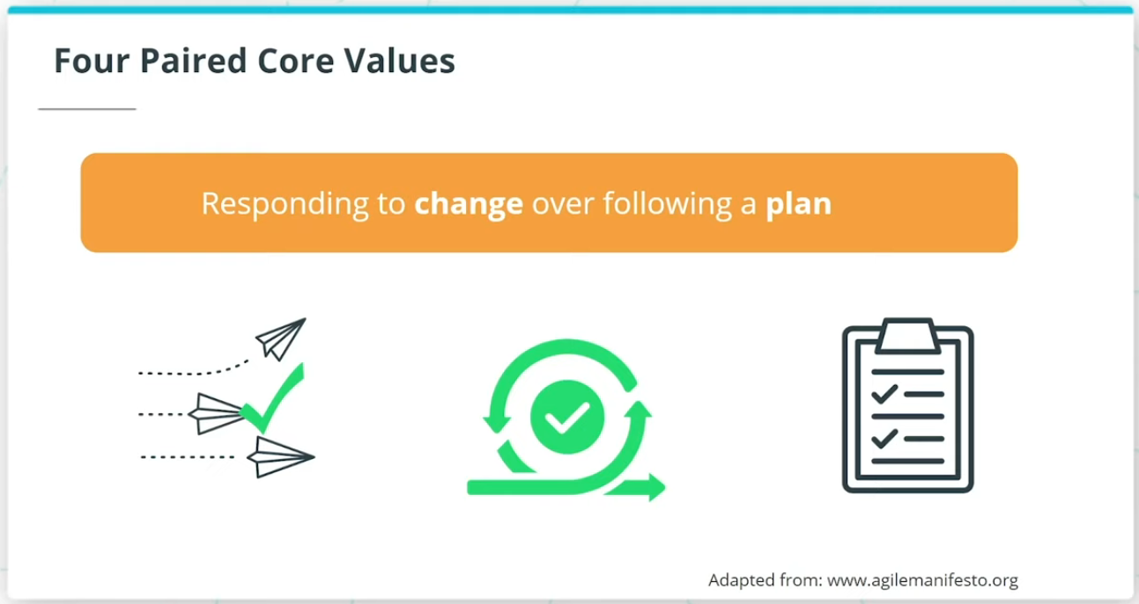

Up until the late 1990s, a majority of product development followed a waterfall-style project development life cycle that was based on adhering to strict processes.

The whole product procedure was process-centric with the goal of delivering the product successfully rather than focusing on delivering a successful product. This is what lead 17 experts to get together and finalize the Agile Manifesto at a meeting in Utah back in 2001.

Up until the late 1990s, a majority of product development followed a waterfall-style project development life cycle that was based on adhering to strict processes.

The whole product procedure was process-centric with the goal of delivering the product successfully rather than focusing on delivering a successful product. This is what lead 17 experts to get together and finalize the Agile Manifesto at a meeting in Utah back in 2001.

### **The 4 Agile Core Values**

These were developed by 17 industry experts and finalized in 2001. They are:

* **Individuals and interactions over processes and tools**: Agile places more importance and emphasis on people and their interactions over processes and even tools.
* **Working software over comprehensive documentation**: Documentation requires a time and resource commitment that might be wasteful.
* **Customer collaboration over contract negotiation**: Agile promotes a collaborative outlook when product owners work with their customers in reaching an agreement on the details of the product delivery.
* **Responding to changes over following a plan**: Agile embraces the change that makes business sense.

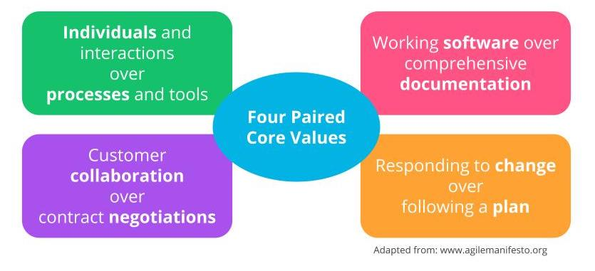

Four Paired Core Values

## The Agile Manifesto Principles

The Agile Manifesto’s 4 paired core values and its associated 12 guiding principles set a solid foundation for the various Agile Frameworks that are currently being practiced by successful organizations in today’s digital age.

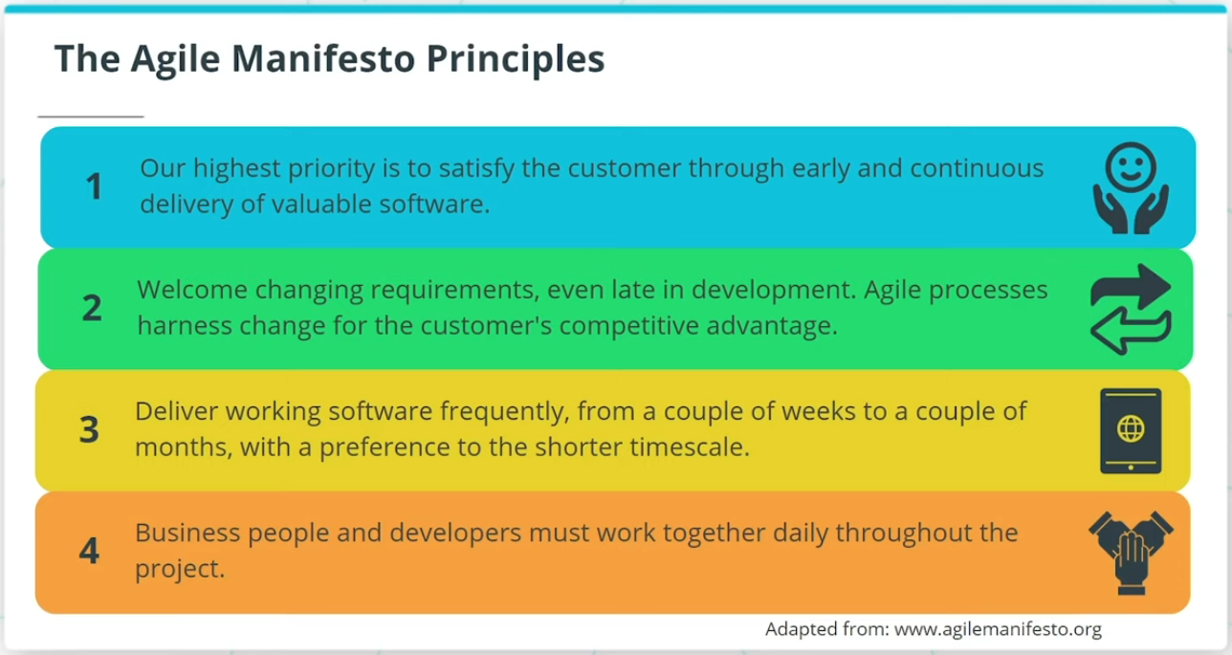

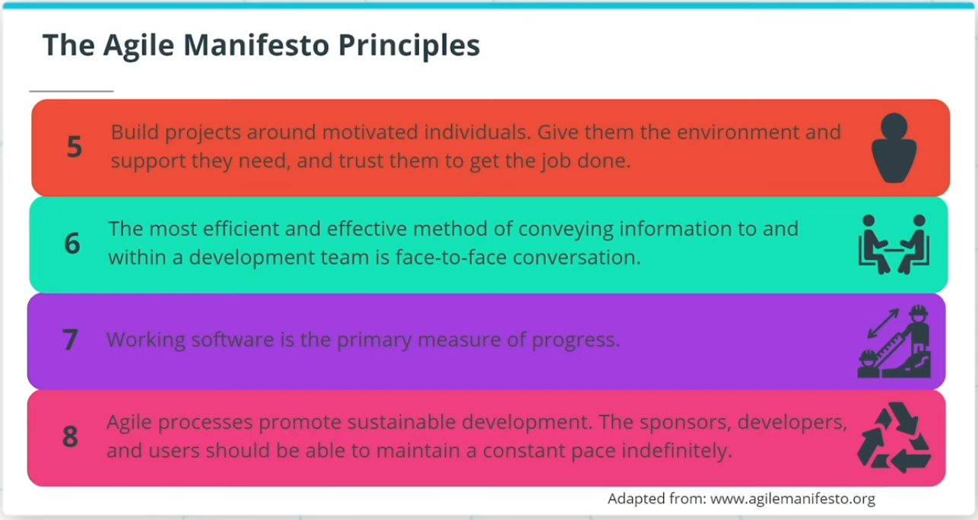

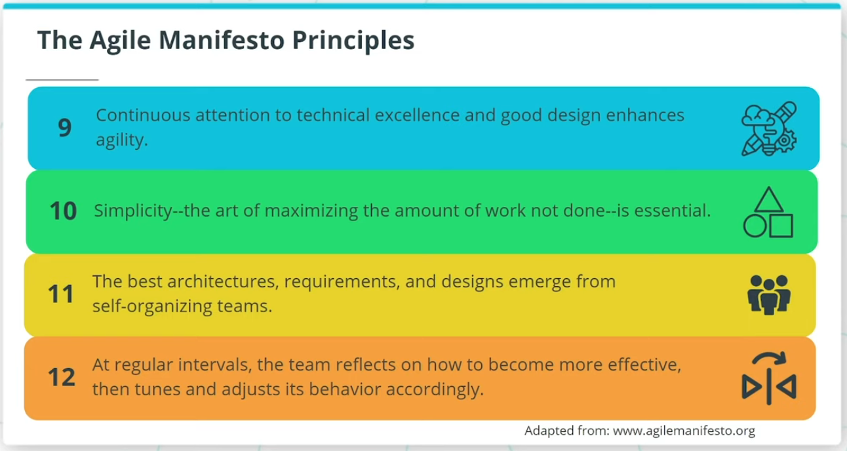

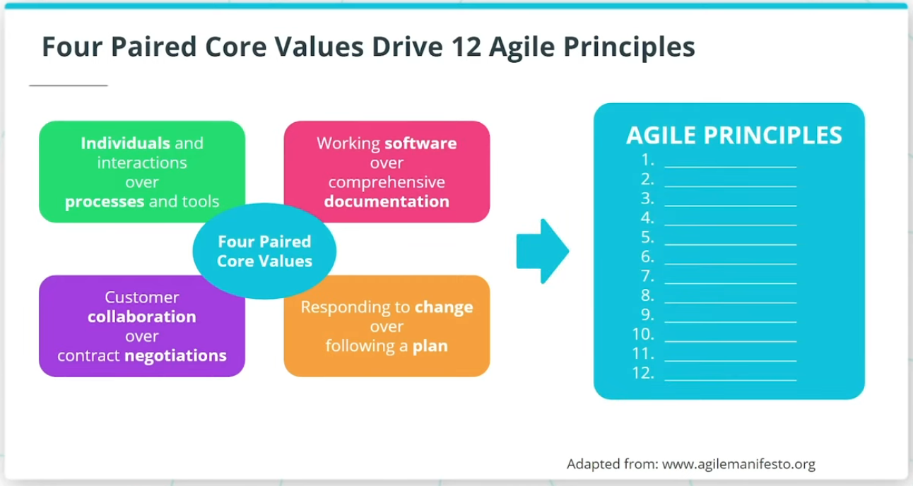

## The 12 Agile Principles

The Agile Manifesto’s 4 paired core values drive the 12 Agile Principles. Let's look at the principles in detail.

1. **Our highest priority is to satisfy the customer through early and continuous delivery of valuable software**. The goal of product development is the development of successful products.
2. **Welcome changing requirements, even late in development. Agile processes harness change for the customer's competitive advantage**. Due to the dynamic competitive landscape, requirements can and will change throughout product development.
3. **Deliver working software frequently, from a couple of weeks to a couple of months, with a preference to the shorter time scale**. Frequent and iterative delivery of working products provides the business with practical feedback.
4. **Business people and developers must work together daily throughout the project**. The Product Owner and the Agile Team adopt practices that ensure inclusive and joint practices.
5. **Build projects around motivated individuals. Give them the environment and support they need, and trust them to get the job done**. Agile leaders build Agile teams with skilled resources who are willing to work together collaboratively with a growth mindset.
6. **The most efficient and effective method of conveying information to and within a development team is face-to-face conversation**. For a product development team to succeed its members must communicate and collaborate effectively.
7. **Working software is the primary measure of progress**. The primary measure of product development should be the delivery of working product increments, which meet the evolving needs of the business.
8. **Agile processes promote sustainable development. The sponsors, developers, and users should be able to maintain a constant pace indefinitely**. A highly skilled team simply just cannot be expected to successfully develop a product by compelling people to work overtime for extended periods.
9. **Continuous attention to technical excellence and good design enhances agility**. Built-in quality practices have enormous benefits. It allows for easier maintenance and scalability of the product.
10. **Simplicity - the art of maximizing the amount of work not done - is essential**. With the guidance of the Product Owner, Agile Teams focus on high-value activities, which allows them to focus on the high business value needs.
11. **The best architectures, requirements, and designs emerge from self-organizing teams**. This is a critical principle of the agile world to ensure that emerging and effective architectures, requirements, and designs are built into the product development life cycle to maximize technical excellence.
12. **At regular intervals, the team reflects on how to become more effective, then tunes and adjusts its behavior accordingly**. Finding concrete opportunities for improvement is a continual effort.

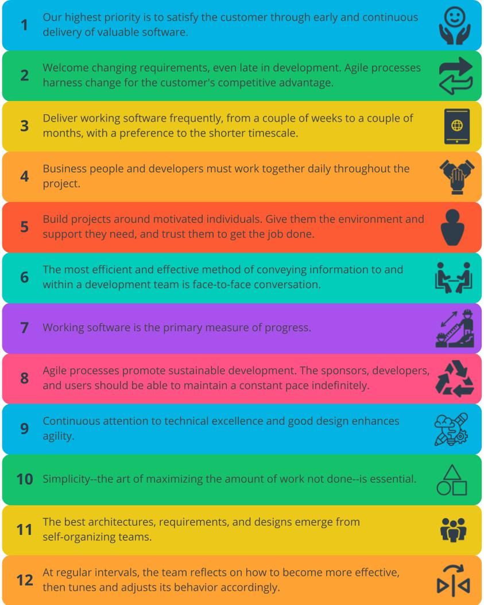

The Agile Manifesto

### **New Terms**

* **Agile Manifesto**: The four paired Core Values and associated 12 Principles that set the foundation for all Agile Frameworks
* **Agile Principles**: Practical guidance for teams to adopt Agile
* **Four Paired Core Values**: The part of the Agile Manifesto that defines the values that establishes what Agile is for teams and organizations

### **Additional Resources**

The Agile Manifesto is worth exploring in depth. These resources should help:

* [**The Agile Manifesto**](http://agilemanifesto.org/): The original Agile Manifesto crafted by 17 industry leaders in 2001.
* [**The Agile Manifesto, Explained**](https://www.projectmanager.com/blog/agile-manifesto-explained): Kris Hughes walks through The Agile Manifesto in detail.

# Quizzes: The Agile Manifesto

## Thinking About the Agile Manifesto

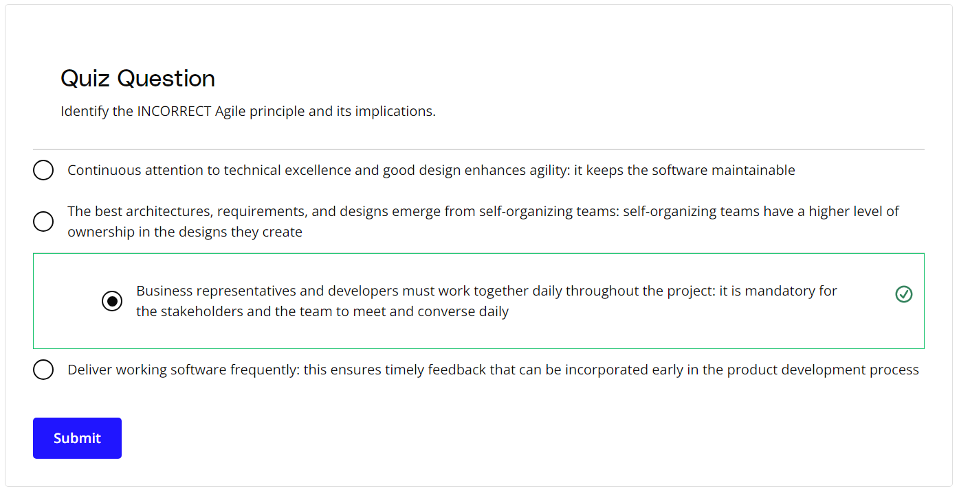

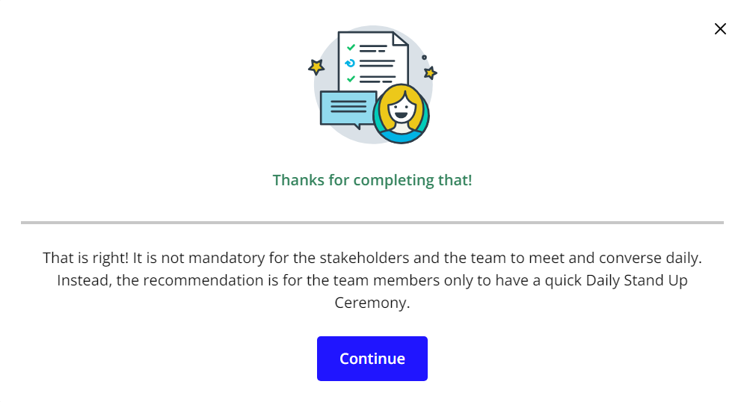

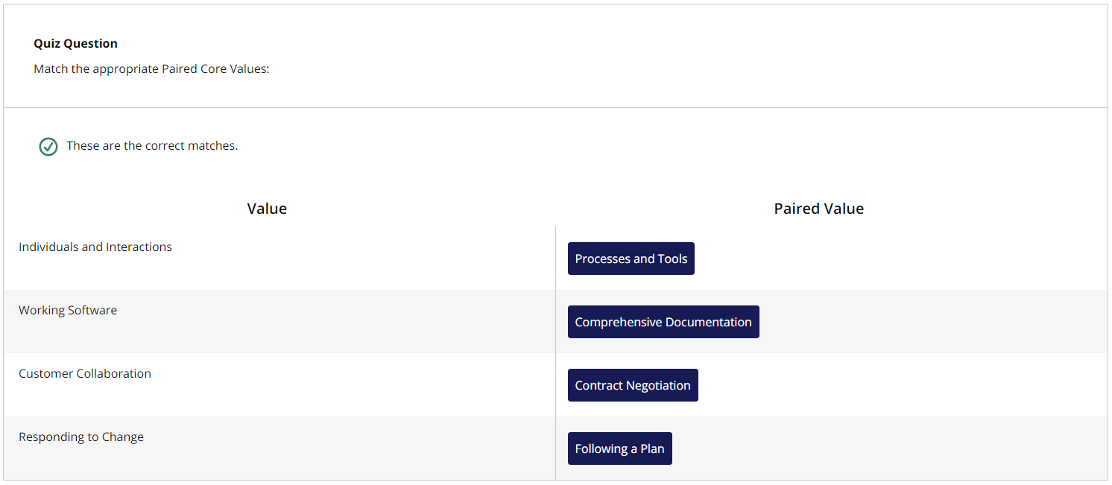

# Exercise: The Agile Manifesto

## Applying the Agile Manifesto

Are the Four Paired Core Values from the Agile Manifesto being followed at SocialKare.gov? Review the [**SocialKare.gov Case Study**](https://video.udacity-data.com/topher/2020/September/5f5f6bc7_agnd-c1-foundations-of-agile-socialkare.gov-case-study/agnd-c1-foundations-of-agile-socialkare.gov-case-study.pdf) and identify the Core Values and Agile Principles that are missing at SocialKare.gov.



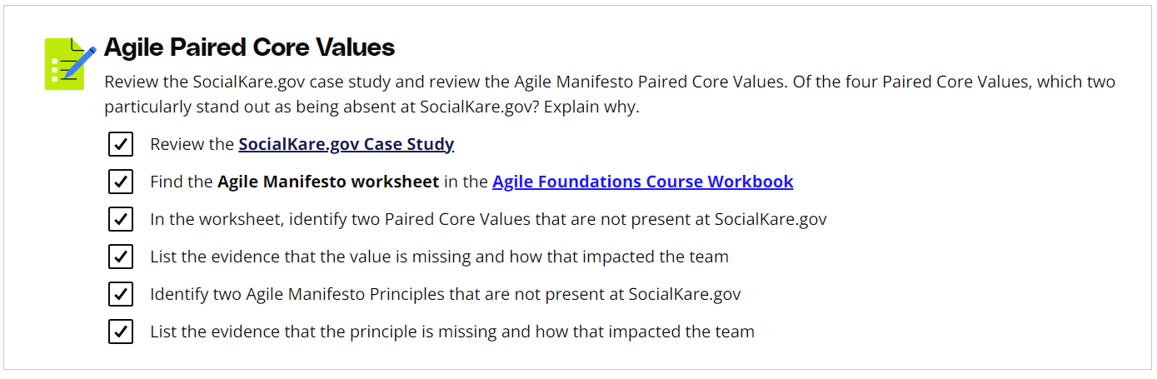

# Solution: The Agile Manifesto

## My Solution

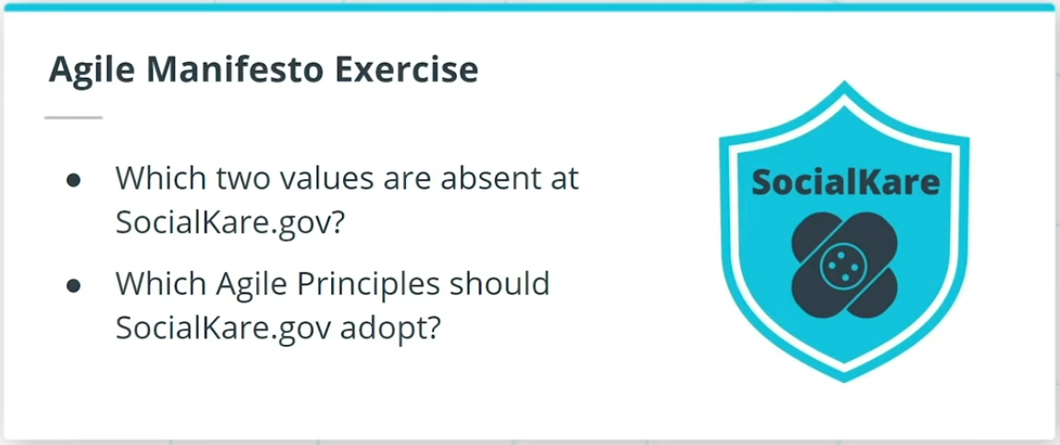

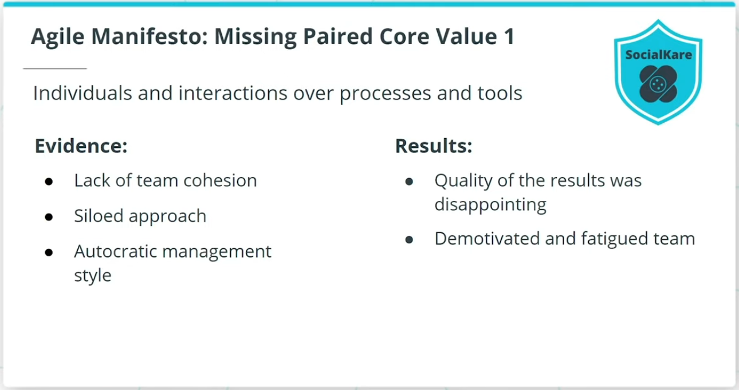

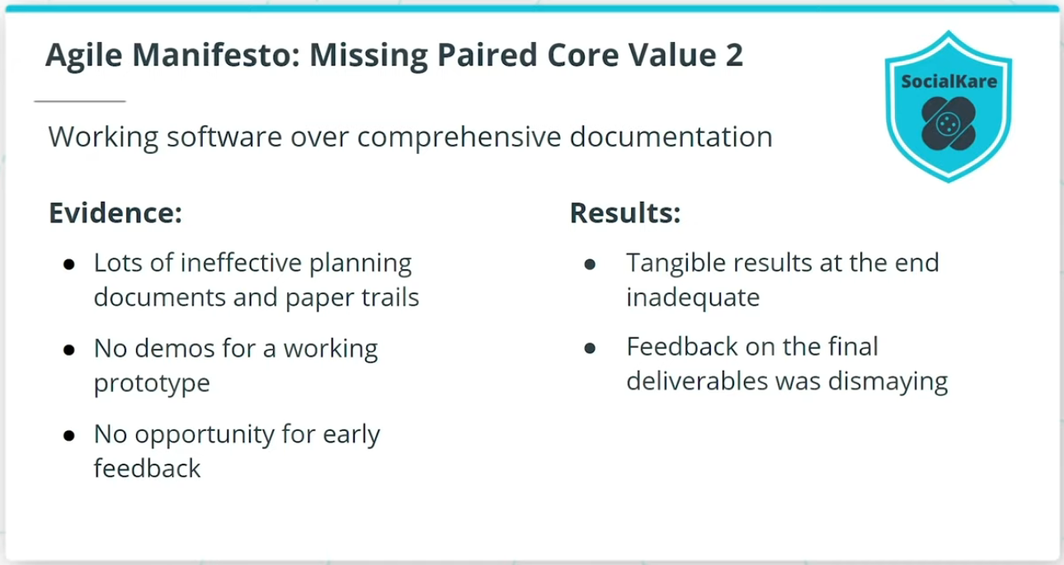

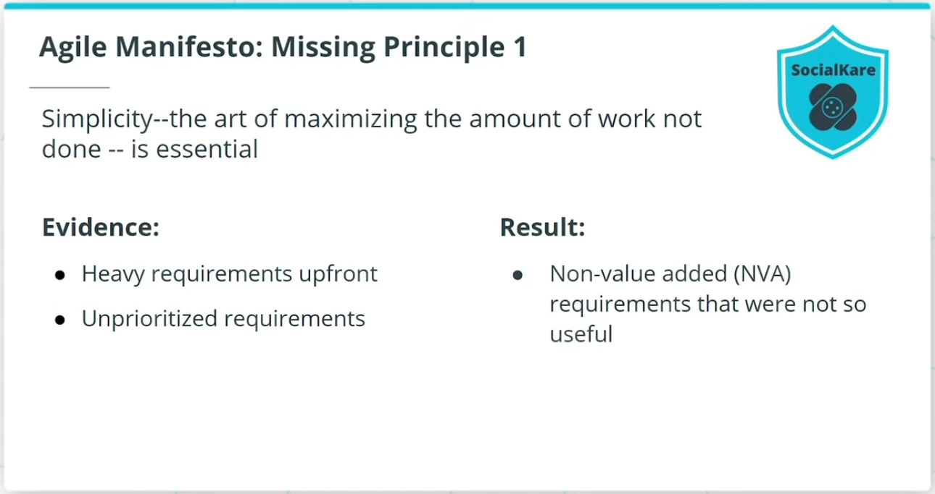

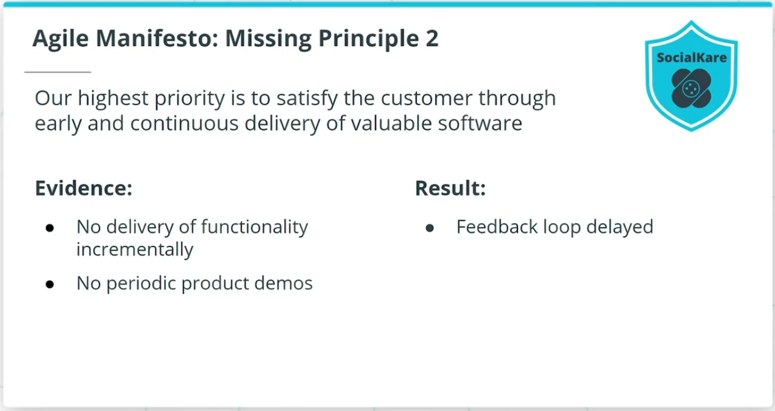

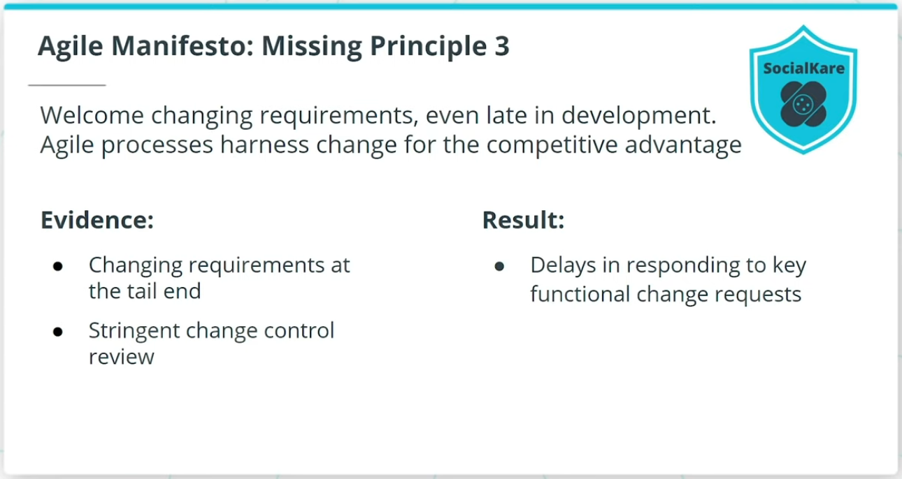

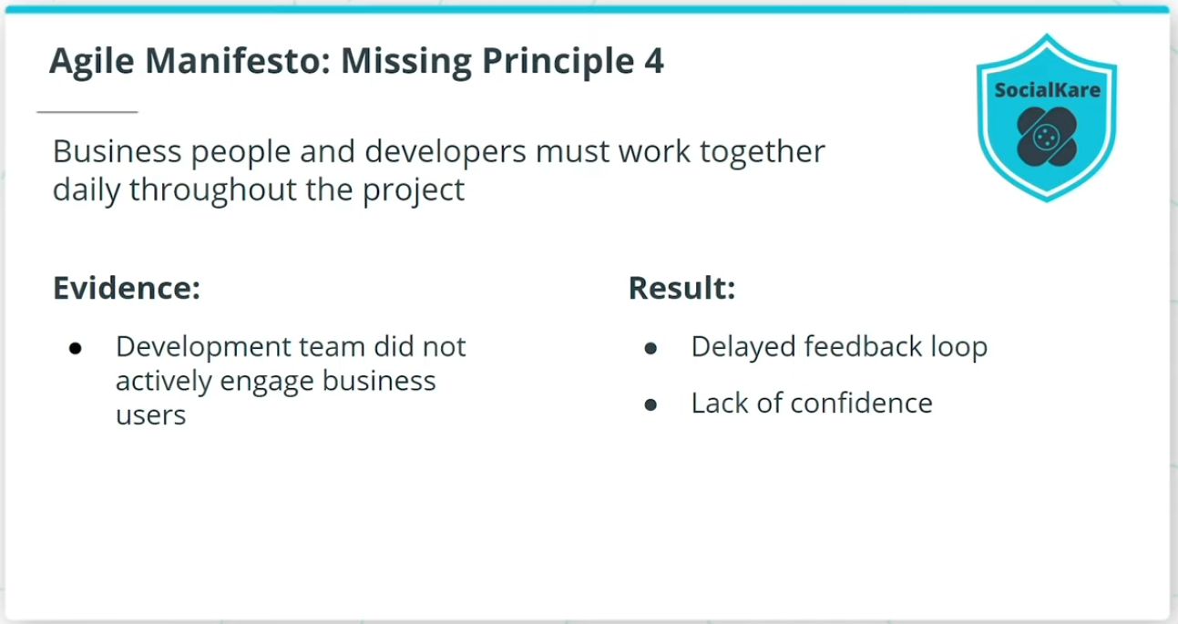

### **The Missing Paired Core Values and Principles**

At least two of the missing Paired Core Values from The Agile Manifesto at SocialKare.gov are:

* Individuals and Interactions over Processes and Tools
* Working Software over Comprehensive Documentation

At least four of the missing Agile Principles at SocialKare.gov are:

* Simplicity--the art of maximizing the amount of work not done--is essential.
* Our highest priority is to satisfy the customer through early and continuous delivery of valuable software.
* Welcome changing requirements, even late in development. Agile processes harness change for the competitive advantage.
* Business people and developers must work together daily throughout the project.

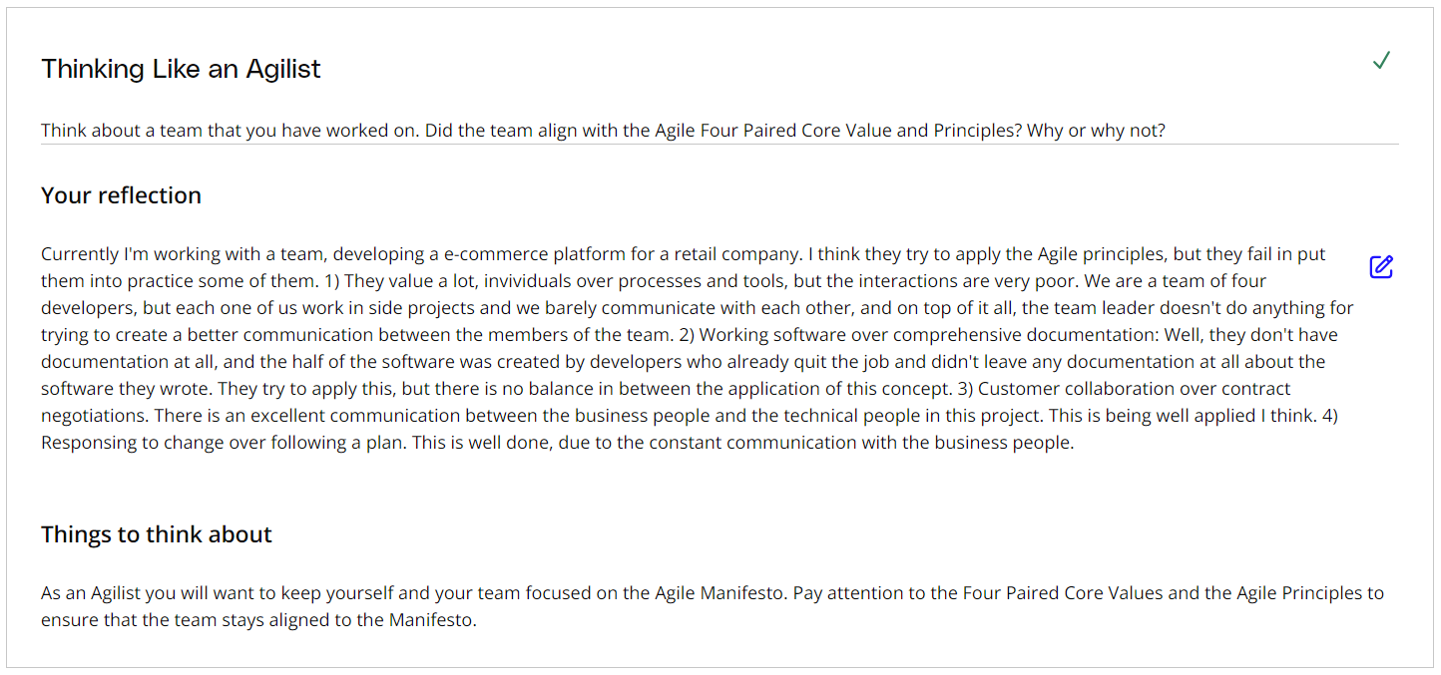

# Agile vs. Waterfall

## Comparing Agile to the Waterfall Methodology

